STUDENT MANAGEMENT SYSTEM

### **AUTHOR**

Name: Gogineni Suhitha

Class: CSE-A

Registration No: AP18110010007

## **CODES AND OUTPUT DISCUSSION**

### **1.LOG IN FORM**

**CODE:**

package loginfile;

import java.awt.EventQueue;

import javax.swing.JFrame;

import javax.swing.JTextField;

import javax.swing.JLabel;

import javax.swing.JOptionPane;

import javax.swing.JPanel;

import java.awt.Font;

import java.awt.event.ActionEvent;

import java.awt.event.ActionListener;

import java.sql.Connection;

import java.sql.DriverManager;

import java.sql.ResultSet;

import java.sql.Statement;

import javax.swing.JRadioButton;

import javax.swing.JButton;

import javax.swing.JPasswordField;

import javax.swing.ImageIcon;

import java.awt.Color;

public class Loginfile {

JFrame frame;

private JTextField textField;

private JPasswordField passwordField;

/**

* Launch the application.

*/

public static void main(String[] args) {

EventQueue.invokeLater(new Runnable() {

public void run() {

try {

Loginfile window = new Loginfile();

window.frame.setVisible(true);

} catch (Exception e) {

e.printStackTrace();

}

}

});

}

/**

* Create the application.

*/

public Loginfile() {

initialize();

}

/**

* Initialize the contents of the frame.

*/

private void initialize() {

frame = new JFrame();

frame.setBounds(100, 100, 911, 666);

frame.setDefaultCloseOperation(JFrame.EXIT_ON_CLOSE);

frame.getContentPane().setLayout(null);

JLabel lblNewLabel = new JLabel("UserName :");

lblNewLabel.setForeground(Color.WHITE);

lblNewLabel.setFont(new Font("Times New Roman", Font.BOLD, 18));

lblNewLabel.setBounds(250, 131, 150, 26);

frame.getContentPane().add(lblNewLabel);

textField = new JTextField();

textField.setFont(new Font("Times New Roman", Font.PLAIN, 14));

textField.setBounds(424, 136, 216, 19);

frame.getContentPane().add(textField);

textField.setColumns(10);

JLabel lblNewLabel_1 = new JLabel("Password :");

lblNewLabel_1.setForeground(Color.WHITE);

lblNewLabel_1.setFont(new Font("Times New Roman", Font.BOLD, 18));

JLabel temp2JLabel = new JLabel("Select any option");

temp2JLabel.setVisible(false);

temp2JLabel.setBounds(200,230,150,20);

JPanel panel2 = new JPanel();

panel2.setBounds(150,230,200,20);

panel2.setVisible(false);

panel2.add(temp2JLabel);

lblNewLabel_1.setBounds(250, 191, 121, 13);

frame.getContentPane().add(lblNewLabel_1);

JRadioButton r1 = new JRadioButton("Admin");

r1.setBackground(Color.ORANGE);

r1.setForeground(new Color(0, 0, 0));

r1.addActionListener(new ActionListener() {

public void actionPerformed(ActionEvent e) {

if(r1.isSelected());

{

r1.setSelected(true);

}

}

});

r1.setFont(new Font("Times New Roman", Font.BOLD, 18));

r1.setBounds(303, 251, 101, 33);

frame.getContentPane().add(r1);

JRadioButton r2 = new JRadioButton("Student");

r2.setBackground(Color.ORANGE);

r2.addActionListener(new ActionListener() {

public void actionPerformed(ActionEvent e) {

if(r2.isSelected());

{

r2.setSelected(true);

r1.setSelected(false);

}

}

});

r2.setFont(new Font("Times New Roman", Font.BOLD, 18));

r2.setBounds(488, 251, 121, 33);

frame.getContentPane().add(r2);

passwordField = new JPasswordField();

passwordField.setFont(new Font("Times New Roman", Font.PLAIN, 14));

passwordField.setBounds(424, 189, 216, 19);

frame.getContentPane().add(passwordField);

JLabel lblNewLabel_2 = new JLabel("Student Management System - April 2020");

lblNewLabel_2.setForeground(Color.WHITE);

lblNewLabel_2.setFont(new Font("Times New Roman", Font.BOLD, 12));

lblNewLabel_2.setBounds(488, 528, 234, 13);

frame.getContentPane().add(lblNewLabel_2);

JLabel lblNewLabel_3 = new JLabel("LOG IN FORM");

lblNewLabel_3.setForeground(Color.ORANGE);

lblNewLabel_3.setFont(new Font("Times New Roman", Font.BOLD, 32));

lblNewLabel_3.setBounds(303, 38, 316, 38);

frame.getContentPane().add(lblNewLabel_3);

JButton btnNewButton_1 = new JButton("CREATE AN ACCOUNT?");

btnNewButton_1.setBackground(Color.ORANGE);

btnNewButton_1.addActionListener(new ActionListener() {

public void actionPerformed(ActionEvent e) {

Regform window = new Regform();

window.frame.setVisible(true);

}

});

btnNewButton_1.setFont(new Font("Times New Roman", Font.BOLD, 16));

btnNewButton_1.setBounds(10, 517, 290, 33);

frame.getContentPane().add(btnNewButton_1);

JButton btnNewButton = new JButton("LOG IN");

btnNewButton.setBackground(Color.ORANGE);

btnNewButton.addActionListener(new ActionListener() {

public void actionPerformed(ActionEvent e) {

//if(idString.equals("AP1234")&& passwordString.equals("srm"))

try {

Class.forName("com.mysql.jdbc.Driver");

Connection con=DriverManager.getConnection("jdbc:mysql://localhost:3306/studentdatabase","root","");

Statement st=con.createStatement();

@SuppressWarnings("deprecation")

String sqlString="Select * from login where UserName='"+textField.getText()+"' and Password='"+passwordField.getText().toString()+"'";

ResultSet rs= st.executeQuery(sqlString);

if(rs.next()) {

JOptionPane.showMessageDialog(frame,"you are successfully logined");

if(r1.isSelected())

{

Adminfile window = new Adminfile();

window.frame.setVisible(true);

}

else if(r2.isSelected())

{

Studentpage window = new Studentpage();

window.frame.setVisible(true);

}

}

else

{

JOptionPane.showMessageDialog(frame,"INVALID DETAILS");

}

con.close();

}

catch (Exception e2) {

System.out.print(e2);

}

// TODO: handle exception

}

});

btnNewButton.setFont(new Font("Times New Roman", Font.BOLD, 18));

btnNewButton.setBounds(358, 324, 150, 38);

frame.getContentPane().add(btnNewButton);

JLabel lblNewLabel_4 = new JLabel("");

lblNewLabel_4.setBackground(Color.ORANGE);

lblNewLabel_4.setIcon(new ImageIcon("C:\\Users\\suhitha\\Desktop\\WhatsApp Image 2020-04-26 at 10.13.43 AM.jpeg"));

lblNewLabel_4.setBounds(-149, -21, 1036, 640);

frame.getContentPane().add(lblNewLabel_4);

JLabel lblNewLabel_5 = new JLabel("New label");

lblNewLabel_5.setBounds(751, 82, 46, 13);

frame.getContentPane().add(lblNewLabel_5);

}

}

##### **OUTPUT:**

LOG IN FORM

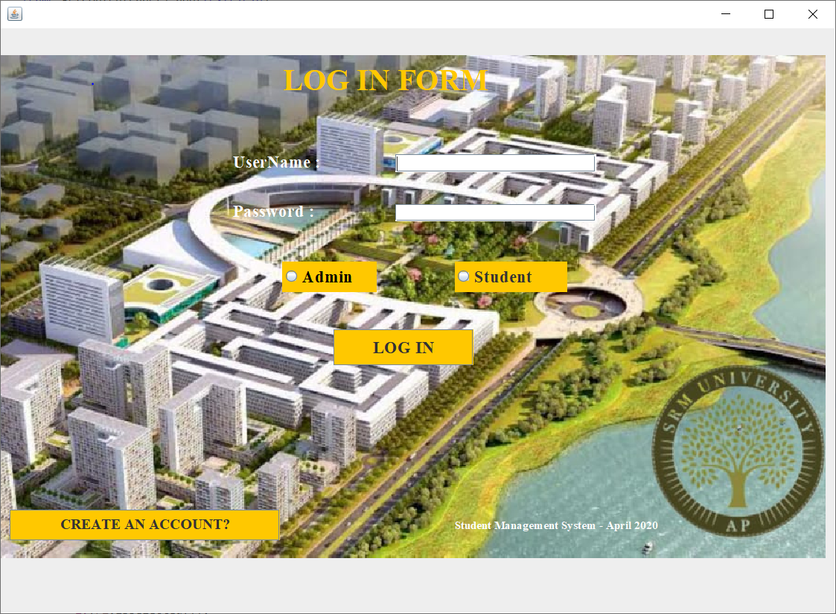

### **2.REGISTRATION FORM**

##### **CODE:**

package loginfile;

import java.awt.EventQueue;

import javax.swing.JFrame;

import javax.swing.JLabel;

import javax.swing.JButton;

import java.awt.Font;

import java.awt.event.ActionListener;

import java.awt.event.ActionEvent;

import javax.swing.ImageIcon;

import java.awt.Color;

public class Regform {

JFrame frame;

/**

* Launch the application.

*/

public static void main(String[] args) {

EventQueue.invokeLater(new Runnable() {

public void run() {

try {

Regform window = new Regform();

window.frame.setVisible(true);

} catch (Exception e) {

e.printStackTrace();

}

}

});

}

/**

* Create the application.

*/

public Regform() {

initialize();

}

/**

* Initialize the contents of the frame.

*/

private void initialize() {

frame = new JFrame();

frame.setDefaultCloseOperation(JFrame.EXIT_ON_CLOSE);

frame.getContentPane().setLayout(null);

JLabel lblNewLabel = new JLabel("REGISTRATION");

lblNewLabel.setForeground(Color.WHITE);

lblNewLabel.setBounds(621, 91, 265, 29);

lblNewLabel.setFont(new Font("Times New Roman", Font.BOLD, 30));

frame.getContentPane().add(lblNewLabel);

JButton btnNewButton = new JButton("REGISTER AS ADMIN");

btnNewButton.setBounds(610, 229, 254, 45);

btnNewButton.addActionListener(new ActionListener() {

public void actionPerformed(ActionEvent e) {

Adminreg window = new Adminreg();

window.frame.setVisible(true);

}

});

btnNewButton.setFont(new Font("Times New Roman", Font.BOLD, 18));

frame.getContentPane().add(btnNewButton);

JButton btnNewButton_2 = new JButton("REGISTER AS STUDENT");

btnNewButton_2.setBounds(610, 334, 254, 45);

btnNewButton_2.addActionListener(new ActionListener() {

public void actionPerformed(ActionEvent e) {

Studentreg window = new Studentreg();

window.frame.setVisible(true);

}

});

btnNewButton_2.setFont(new Font("Times New Roman", Font.BOLD, 18));

frame.getContentPane().add(btnNewButton_2);

JButton btnNewButton_4 = new JButton("OR CLICK HERE TO LOGIN");

btnNewButton_4.setBounds(46, 529, 236, 38);

btnNewButton_4.addActionListener(new ActionListener() {

public void actionPerformed(ActionEvent e) {

Loginfile window = new Loginfile();

window.frame.setVisible(true);

}

});

btnNewButton_4.setFont(new Font("Times New Roman", Font.BOLD, 14));

frame.getContentPane().add(btnNewButton_4);

JLabel lblNewLabel_1 = new JLabel("");

lblNewLabel_1.setIcon(new ImageIcon("C:\\Users\\suhitha\\Desktop\\Webp.net-resizeimage.jpg"));

lblNewLabel_1.setBounds(10, 10, 1076, 585);

frame.getContentPane().add(lblNewLabel_1);

}

}

#### **OUTPUT:**

##### REGISTRATION FORM

If “CREATE AN ACCOUNT?” button is clicked page directs to the registration form page and if the user already has an account then he/she can click on “OR CLICK HERE TO LOGIN” button to redirect to the login in form.

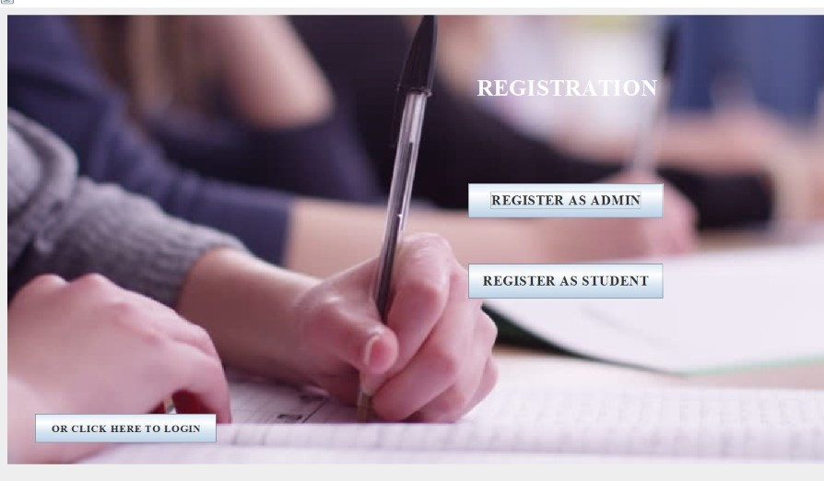

#### **3. ADMIN REGISTRATION**

##### **CODE:**

package loginfile;

import java.awt.EventQueue;

import java.awt.Font;

import javax.swing.JButton;

import javax.swing.JFrame;

import javax.swing.JLabel;

import javax.swing.JOptionPane;

import javax.swing.JPasswordField;

import javax.swing.JTextField;

import java.awt.event.ActionListener;

import java.awt.event.ActionEvent;

//import java.io.*;

//import java.io.File;

import javax.swing.ImageIcon;

import java.awt.Color;

import java.sql.*;

public class Adminreg {

JFrame frame;

private JTextField T1;

private JTextField T2;

private JTextField T3;

private JPasswordField P1;

private JTextField T5;

private JTextField T6;

private JTextField textField_5;

private JTextField T4;

/**

* Launch the application.

*/

public static void main(String[] args) {

EventQueue.invokeLater(new Runnable() {

public void run() {

try {

Adminreg window = new Adminreg();

window.frame.setVisible(true);

} catch (Exception e) {

e.printStackTrace();

}

}

});

}

/**

* Create the application.

*/

public Adminreg() {

initialize();

}

/**

* Initialize the contents of the frame.

*/

private void initialize() {

frame = new JFrame();

frame.setBounds(100, 100, 1279, 769);

frame.setDefaultCloseOperation(JFrame.EXIT_ON_CLOSE);

frame.getContentPane().setLayout(null);

JLabel lblNewLabel = new JLabel("ADMIN REGISTRATION");

lblNewLabel.setForeground(Color.WHITE);

lblNewLabel.setFont(new Font("Times New Roman", Font.BOLD, 30));

lblNewLabel.setBounds(459, 50, 377, 29);

frame.getContentPane().add(lblNewLabel);

JLabel lblNewLabel_1 = new JLabel("UserName");

lblNewLabel_1.setForeground(Color.WHITE);

lblNewLabel_1.setFont(new Font("Times New Roman", Font.BOLD, 14));

lblNewLabel_1.setBounds(118, 201, 78, 16);

frame.getContentPane().add(lblNewLabel_1);

JLabel lblNewLabel_2 = new JLabel("Name");

lblNewLabel_2.setForeground(Color.WHITE);

lblNewLabel_2.setFont(new Font("Times New Roman", Font.BOLD, 14));

lblNewLabel_2.setBounds(118, 261, 62, 16);

frame.getContentPane().add(lblNewLabel_2);

JLabel lblNewLabel_3 = new JLabel("Email");

lblNewLabel_3.setForeground(Color.WHITE);

lblNewLabel_3.setFont(new Font("Times New Roman", Font.BOLD, 14));

lblNewLabel_3.setBounds(118, 315, 62, 13);

frame.getContentPane().add(lblNewLabel_3);

JLabel lblNewLabel_4 = new JLabel("Password");

lblNewLabel_4.setForeground(Color.WHITE);

lblNewLabel_4.setFont(new Font("Times New Roman", Font.BOLD, 14));

lblNewLabel_4.setBounds(118, 383, 78, 13);

frame.getContentPane().add(lblNewLabel_4);

JLabel lblNewLabel_5 = new JLabel("Gender");

lblNewLabel_5.setForeground(Color.WHITE);

lblNewLabel_5.setFont(new Font("Times New Roman", Font.BOLD, 14));

lblNewLabel_5.setBounds(668, 203, 62, 13);

frame.getContentPane().add(lblNewLabel_5);

JLabel lblNewLabel_6 = new JLabel("Phone");

lblNewLabel_6.setForeground(Color.WHITE);

lblNewLabel_6.setFont(new Font("Times New Roman", Font.BOLD, 14));

lblNewLabel_6.setBounds(666, 261, 46, 13);

frame.getContentPane().add(lblNewLabel_6);

JLabel lblNewLabel_7 = new JLabel("Address");

lblNewLabel_7.setForeground(Color.WHITE);

lblNewLabel_7.setFont(new Font("Times New Roman", Font.BOLD, 14));

lblNewLabel_7.setBounds(666, 315, 62, 13);

frame.getContentPane().add(lblNewLabel_7);

T1 = new JTextField();

T1.setBounds(258, 198, 211, 19);

frame.getContentPane().add(T1);

T1.setColumns(10);

T2 = new JTextField();

T2.setBounds(258, 261, 205, 19);

frame.getContentPane().add(T2);

T2.setColumns(10);

T3 = new JTextField();

T3.setBounds(258, 313, 205, 19);

frame.getContentPane().add(T3);

T3.setColumns(10);

P1 = new JPasswordField();

P1.setBounds(258, 381, 211, 19);

frame.getContentPane().add(P1);

T5 = new JTextField();

T5.setBounds(813, 261, 180, 19);

frame.getContentPane().add(T5);

T5.setColumns(10);

T6 = new JTextField();

T6.setBounds(813, 313, 230, 147);

frame.getContentPane().add(T6);

T6.setColumns(10);

T4 = new JTextField();

T4.setBounds(813, 201, 180, 19);

frame.getContentPane().add(T4);

T4.setColumns(10);

JButton btnNewButton_1 = new JButton("REGISTER");

btnNewButton_1.setForeground(Color.BLACK);

btnNewButton_1.setBackground(Color.WHITE);

btnNewButton_1.addActionListener(new ActionListener() {

@SuppressWarnings("deprecation")

public void actionPerformed(ActionEvent e) {

/*

String a = T1.getText().toString();

String b = T2.getText().toString();

String c = T3.getText().toString();

@SuppressWarnings("deprecation")

String g = P1.getText().toString();

String h = T4.getText().toString();

String i = T5.getText().toString();

String k = T6.getText().toString();

try {

File file = new File("C:\\users\\suhitha\\Desktop\\Adminreg");

FileWriter fw= new FileWriter (file,true);

fw.write(a+"\n");

fw.write(b+"\n");

fw.write(c+"\n");

fw.write(g+"\n");

fw.write(h+"\n");

fw.write(i+"\n");

fw.write(k+"\n");

fw.write("------------------------\n");

fw.close();

JOptionPane.showMessageDialog(null,"you are successfully registered");

System.exit(0);

} catch (Exception e2) {

// TODO: handle exception

JOptionPane.showMessageDialog(null,"Please enter all the information needed");

System.exit(0);

}

*/

try {

Class.forName("com.mysql.jdbc.Driver");

Connection con=DriverManager.getConnection("jdbc:mysql://localhost:3306/studentdatabase","root","");

PreparedStatement ps=con.prepareStatement("insert into admin_registration(UserName,Name,Email,Password,Gender,Phone,Address)values(?,?,?,?,?,?,?)");

ps.setString(1, T1.getText());

ps.setString(2, T2.getText());

ps.setString(3, T3.getText());

ps.setString(4, P1.getText());

ps.setString(5, T4.getText());

ps.setString(6, T5.getText());

ps.setString(7, T6.getText());

int x =ps.executeUpdate();

if(x>0) {

System.out.println("You are successfully registered");

JOptionPane.showMessageDialog(frame,"You are successfully registered");

}

else {

System.out.println("registration failed");

JOptionPane.showMessageDialog(frame,"registration failed");

System.exit(0);

}

} catch (Exception e2) {

// TODO: handle exception

System.out.println(e2);

}

}

});

btnNewButton_1.setFont(new Font("Times New Roman", Font.BOLD, 16));

btnNewButton_1.setBounds(555, 563, 142, 42);

frame.getContentPane().add(btnNewButton_1);

textField_5 = new JTextField();

textField_5.setBounds(813, 201, 173, 19);

frame.getContentPane().add(textField_5);

textField_5.setColumns(10);

JButton btnNewButton = new JButton("BACK");

btnNewButton.addActionListener(new ActionListener() {

public void actionPerformed(ActionEvent e) {

Loginfile window = new Loginfile();

window.frame.setVisible(true);

}

});

btnNewButton.setFont(new Font("Times New Roman", Font.BOLD, 16));

btnNewButton.setBounds(46, 660, 120, 42);

frame.getContentPane().add(btnNewButton);

JLabel lblNewLabel_8 = new JLabel("");

lblNewLabel_8.setIcon(new ImageIcon("C:\\Users\\suhitha\\Desktop\\Webp.net-resizeimage.jpg"));

lblNewLabel_8.setBounds(10, 23, 1226, 687);

frame.getContentPane().add(lblNewLabel_8);

}

}

#### **OUTPUT:**

ADMIN REGISTRATION

If the user clicks “ REGISTER AS ADMIN” button then the page directs to the admin registration form and all the details entered are stored into the database.

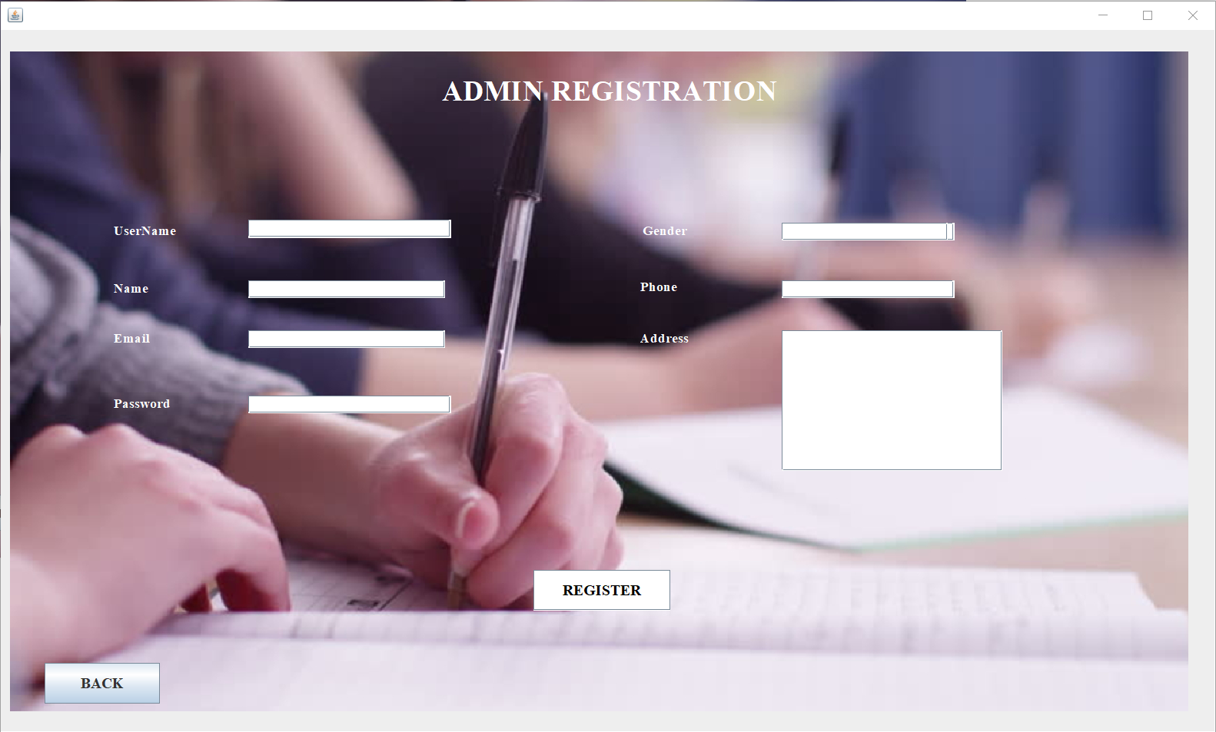

After clicking on “REGISTER” button user gets an alert message as of follows:

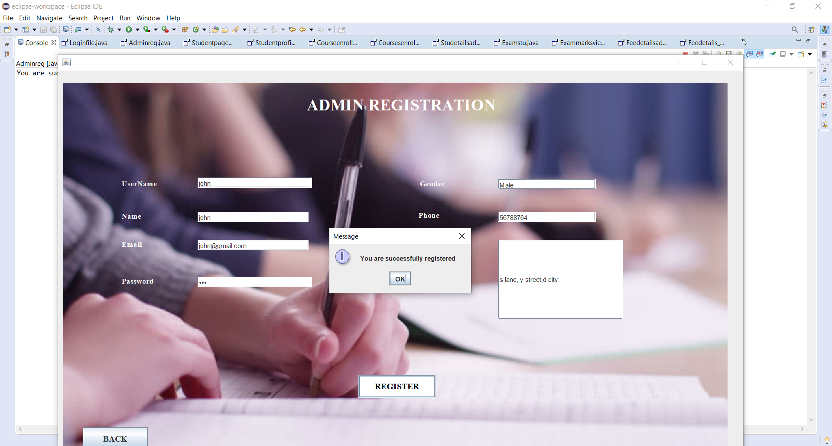

#### **4. STUDENT REGISTRATION**

##### **CODE:**

package loginfile;

import java.awt.EventQueue;

import javax.swing.JFrame;

import javax.swing.JLabel;

import javax.swing.JOptionPane;

import java.awt.Font;

import javax.swing.JButton;

import javax.swing.JTextField;

import javax.swing.JPasswordField;

import java.awt.event.ActionListener;

import java.awt.event.ActionEvent;

//import java.io.*;

//import java.io.File;

import javax.swing.ImageIcon;

import java.awt.Color;

import java.sql.*;

public class Studentreg{

JFrame frame;

private JTextField T1;

private JTextField T2;

private JTextField T3;

private JTextField T4;

private JTextField T5;

private JTextField T6;

private JTextField T7;

private JPasswordField p1;

private JTextField T8;

private JTextField T9;

/**

* Launch the application.

*/

public static void main(String[] args) {

EventQueue.invokeLater(new Runnable() {

public void run() {

try {

Studentreg window = new Studentreg();

window.frame.setVisible(true);

} catch (Exception e) {

e.printStackTrace();

}

}

});

}

/**

* Create the application.

*/

public Studentreg() {

initialize();

}

/**

* Initialize the contents of the frame.

*/

private void initialize() {

frame = new JFrame();

frame.setBounds(100, 100, 1149, 679);

frame.setDefaultCloseOperation(JFrame.EXIT_ON_CLOSE);

frame.getContentPane().setLayout(null);

JLabel lblNewLabel = new JLabel("STUDENT REGISTRATION");

lblNewLabel.setForeground(Color.WHITE);

lblNewLabel.setFont(new Font("Times New Roman", Font.BOLD, 30));

lblNewLabel.setBounds(379, 44, 399, 29);

frame.getContentPane().add(lblNewLabel);

JLabel lblNewLabel_1 = new JLabel("UserName");

lblNewLabel_1.setForeground(Color.WHITE);

lblNewLabel_1.setFont(new Font("Times New Roman", Font.BOLD, 14));

lblNewLabel_1.setBounds(117, 165, 70, 21);

frame.getContentPane().add(lblNewLabel_1);

JLabel lblNewLabel_2 = new JLabel("Name");

lblNewLabel_2.setForeground(Color.WHITE);

lblNewLabel_2.setFont(new Font("Times New Roman", Font.BOLD, 14));

lblNewLabel_2.setBounds(117, 217, 58, 21);

frame.getContentPane().add(lblNewLabel_2);

JLabel lblNewLabel_3 = new JLabel("Email");

lblNewLabel_3.setForeground(Color.WHITE);

lblNewLabel_3.setFont(new Font("Times New Roman", Font.BOLD, 14));

lblNewLabel_3.setBounds(117, 267, 46, 21);

frame.getContentPane().add(lblNewLabel_3);

JLabel lblNewLabel_4 = new JLabel("StudentID");

lblNewLabel_4.setForeground(Color.WHITE);

lblNewLabel_4.setFont(new Font("Times New Roman", Font.BOLD, 14));

lblNewLabel_4.setBounds(117, 319, 70, 21);

frame.getContentPane().add(lblNewLabel_4);

JLabel lblNewLabel_5 = new JLabel("Section");

lblNewLabel_5.setForeground(Color.WHITE);

lblNewLabel_5.setFont(new Font("Times New Roman", Font.BOLD, 14));

lblNewLabel_5.setBounds(117, 375, 58, 21);

frame.getContentPane().add(lblNewLabel_5);

JLabel lblNewLabel_7 = new JLabel("Date of Birth");

lblNewLabel_7.setForeground(Color.WHITE);

lblNewLabel_7.setFont(new Font("Times New Roman", Font.BOLD, 14));

lblNewLabel_7.setBounds(544, 169, 85, 17);

frame.getContentPane().add(lblNewLabel_7);

JLabel lblNewLabel_8 = new JLabel("Phone ");

lblNewLabel_8.setForeground(Color.WHITE);

lblNewLabel_8.setFont(new Font("Times New Roman", Font.BOLD, 14));

lblNewLabel_8.setBounds(544, 271, 58, 13);

frame.getContentPane().add(lblNewLabel_8);

JLabel lblNewLabel_9 = new JLabel("Address");

lblNewLabel_9.setForeground(Color.WHITE);

lblNewLabel_9.setFont(new Font("Times New Roman", Font.BOLD, 14));

lblNewLabel_9.setBounds(539, 321, 63, 21);

frame.getContentPane().add(lblNewLabel_9);

JButton btnNewButton_2 = new JButton("REGISTER");

btnNewButton_2.addActionListener(new ActionListener() {

@SuppressWarnings("deprecation")

public void actionPerformed(ActionEvent e) {

/*

String a = T1.getText().toString();

String b = T2.getText().toString();

String c = T3.getText().toString();

String d = T4.getText().toString();

String f = T8.getText().toString();

@SuppressWarnings("deprecation")

String g = p1.getText().toString();

String h = T5.getText().toString();

String i = T9.getText().toString();

String k = T6.getText().toString();

String l = T7.getText().toString();

try {

File file = new File("C:\\Users\\suhitha\\Desktop\\STUdent registration.txt");

FileWriter fw= new FileWriter (file,true);

fw.write(a+"\n");

fw.write(b+"\n");

fw.write(c+"\n");

fw.write(d+"\n");

fw.write(f+"\n");

fw.write(g+"\n");

fw.write(h+"\n");

fw.write(i+"\n");

fw.write(k+"\n");

fw.write(l+"\n");

fw.write("------------------------\n");

fw.close();

JOptionPane.showMessageDialog(null,"you are successfully registered");

System.exit(0);

} catch (Exception e2) {

// TODO: handle exception

JOptionPane.showMessageDialog(null,"Please enter all the information needed");

System.exit(0);

}

*/

try {

Class.forName("com.mysql.jdbc.Driver");

Connection con=DriverManager.getConnection("jdbc:mysql://localhost:3306/studentdatabase","root","");

PreparedStatement ps=con.prepareStatement("insert into student_registration values(?,?,?,?,?,?,?,?,?,?)");

ps.setString(1, T1.getText());

ps.setString(2, T2.getText());

ps.setString(3, T3.getText());

ps.setString(4, T4.getText());

ps.setString(5, T8.getText());

ps.setString(6, p1.getText());

ps.setString(7, T5.getText());

ps.setString(8, T9.getText());

ps.setString(9, T6.getText());

ps.setString(10,T7.getText());

int x =ps.executeUpdate();

if(x>0) {

System.out.println("You are successfully registered");

JOptionPane.showMessageDialog(frame,"You are successfully registered");

}

else {

System.out.println("registration failed");

System.exit(0);

JOptionPane.showMessageDialog(frame,"registration failed");

}

} catch (Exception e2) {

// TODO: handle exception

System.out.println(e2);

}

}

});

btnNewButton_2.setFont(new Font("Times New Roman", Font.BOLD, 16));

btnNewButton_2.setBounds(471, 540, 131, 40);

frame.getContentPane().add(btnNewButton_2);

T1 = new JTextField();

T1.setBounds(236, 167, 190, 19);

frame.getContentPane().add(T1);

T1.setColumns(10);

T2 = new JTextField();

T2.setBounds(236, 219, 190, 19);

frame.getContentPane().add(T2);

T2.setColumns(10);

T3 = new JTextField();

T3.setBounds(236, 269, 190, 19);

frame.getContentPane().add(T3);

T3.setColumns(10);

T4 = new JTextField();

T4.setBounds(236, 321, 190, 19);

frame.getContentPane().add(T4);

T4.setColumns(10);

T5 = new JTextField();

T5.setBounds(685, 167, 126, 19);

frame.getContentPane().add(T5);

T5.setColumns(10);

JLabel lblNewLabel_10 = new JLabel("Gender");

lblNewLabel_10.setForeground(Color.WHITE);

lblNewLabel_10.setFont(new Font("Times New Roman", Font.BOLD, 14));

lblNewLabel_10.setBounds(544, 222, 70, 16);

frame.getContentPane().add(lblNewLabel_10);

JLabel lblNewLabel_11 = new JLabel("Enter password");

lblNewLabel_11.setForeground(Color.WHITE);

lblNewLabel_11.setFont(new Font("Times New Roman", Font.BOLD, 14));

lblNewLabel_11.setBounds(117, 417, 118, 21);

frame.getContentPane().add(lblNewLabel_11);

T6 = new JTextField();

T6.setBounds(685, 269, 126, 19);

frame.getContentPane().add(T6);

T6.setColumns(10);

T7 = new JTextField();

T7.setBounds(685, 321, 241, 119);

frame.getContentPane().add(T7);

T7.setColumns(10);

p1 = new JPasswordField();

p1.setBounds(236, 419, 190, 19);

frame.getContentPane().add(p1);

T8 = new JTextField();

T8.setBounds(236, 377, 190, 19);

frame.getContentPane().add(T8);

T8.setColumns(10);

T9 = new JTextField();

T9.setBounds(685, 219, 126, 19);

frame.getContentPane().add(T9);

T9.setColumns(10);

JButton btnNewButton = new JButton("BACK");

btnNewButton.addActionListener(new ActionListener() {

public void actionPerformed(ActionEvent e) {

Loginfile window = new Loginfile();

window.frame.setVisible(true);

}

});

btnNewButton.setBackground(Color.WHITE);

btnNewButton.setForeground(new Color(0, 0, 0));

btnNewButton.setFont(new Font("Times New Roman", Font.BOLD, 18));

btnNewButton.setBounds(33, 592, 111, 40);

frame.getContentPane().add(btnNewButton);

JLabel lblNewLabel_6 = new JLabel("");

lblNewLabel_6.setIcon(new ImageIcon("C:\\Users\\suhitha\\Desktop\\Webp.net-resizeimage.jpg"));

lblNewLabel_6.setBounds(0, 10, 1125, 632);

frame.getContentPane().add(lblNewLabel_6);

}

}

##### 

##### 

##### 

##### **OUTPUT:**

STUDENT REGISTRATION

If the user clicks on “ REGISTER AS STUDENT” button then the page directs to the student registration form and all the details entered are stored into the database.

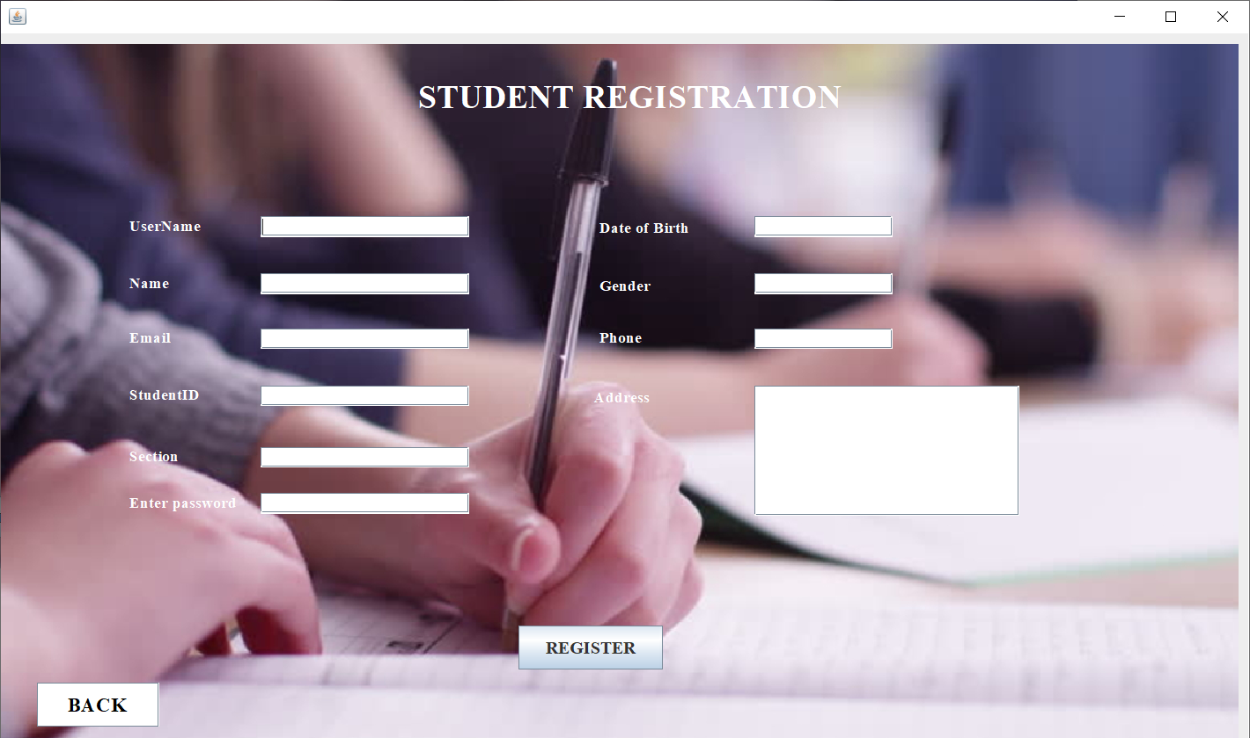

After clicking on “REGISTER” button user gets an alert message as of follows:

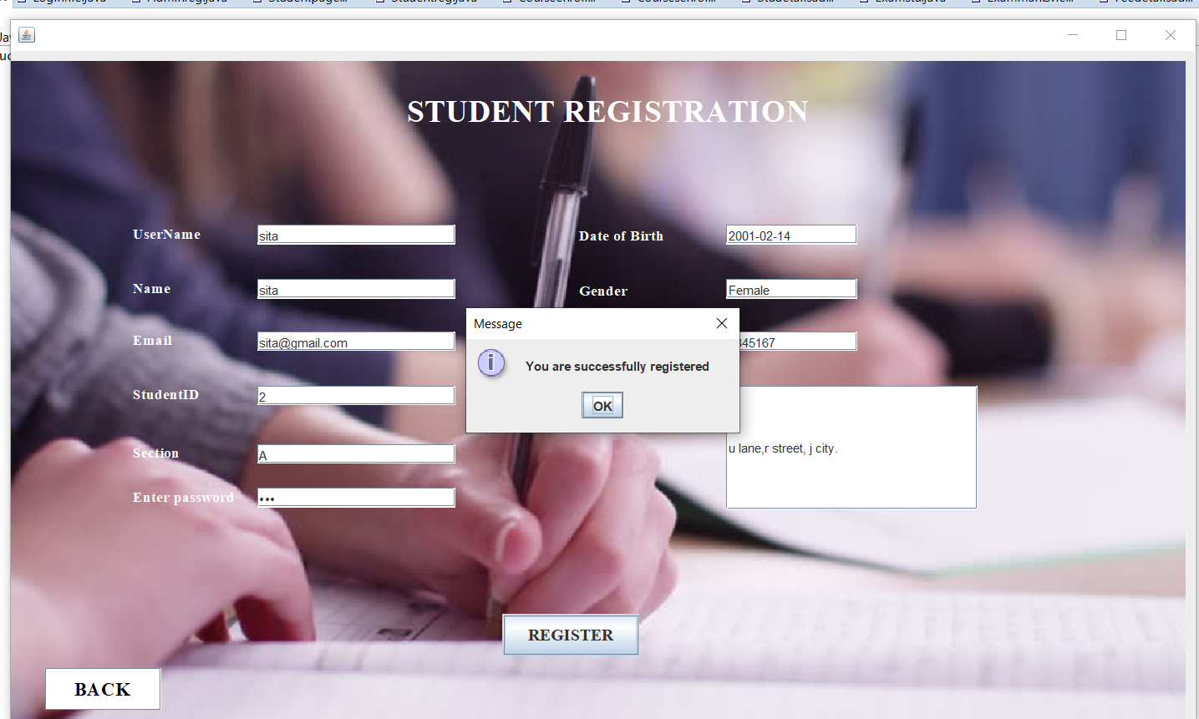

#### **LOG IN FORM**

##### **OUTPUT:**

If the user selects “ADMIN” or “STUDENT” radio buttons after entering the username and password then we do get some alert messages as of follows:

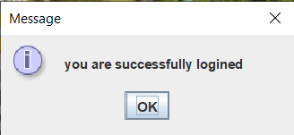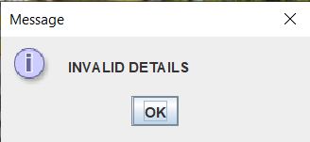

#### **5. ADMIN SECTION**

#### **CODE:**

package loginfile;

import java.awt.EventQueue;

import java.awt.Font;

import java.awt.event.ActionEvent;

import java.awt.event.ActionListener;

import javax.swing.JButton;

import javax.swing.JFrame;

import javax.swing.JLabel;

import javax.swing.ImageIcon;

import java.awt.Color;

public class Adminfile {

JFrame frame;

/**

* Launch the application.

*/

public static void main(String[] args) {

EventQueue.invokeLater(new Runnable() {

public void run() {

try {

Adminfile window = new Adminfile();

window.frame.setVisible(true);

} catch (Exception e) {

e.printStackTrace();

}

}

});

}

/**

* Create the application.

*/

public Adminfile() {

initialize();

}

private void initialize() {

frame = new JFrame();

frame.getContentPane().setFont(new Font("Times New Roman", Font.BOLD, 18));

frame.setBounds(100, 100, 1203, 684);

frame.setDefaultCloseOperation(JFrame.EXIT_ON_CLOSE);

frame.getContentPane().setLayout(null);

JLabel lblNewLabel = new JLabel("ADMIN SECTION");

lblNewLabel.setForeground(Color.WHITE);

lblNewLabel.setFont(new Font("Times New Roman", Font.BOLD, 28));

lblNewLabel.setBounds(462, 36, 395, 29);

frame.getContentPane().add(lblNewLabel);

JButton btnNewButton = new JButton("STUDENT DETAILS");

btnNewButton.addActionListener(new ActionListener() {

public void actionPerformed(ActionEvent e) {

Studetailsadmin frame = new Studetailsadmin();

frame.setVisible(true);

}

});

btnNewButton.setFont(new Font("Times New Roman", Font.BOLD, 14));

btnNewButton.setBounds(479, 180, 196, 41);

frame.getContentPane().add(btnNewButton);

JButton btnNewButton_6 = new JButton("COURSES ENROLLED");

btnNewButton_6.addActionListener(new ActionListener() {

public void actionPerformed(ActionEvent e) {

Coursesenrolledadmin frame = new Coursesenrolledadmin();

frame.setVisible(true);

}

});

btnNewButton_6.setFont(new Font("Times New Roman", Font.BOLD, 14));

btnNewButton_6.setBounds(479, 371, 196, 35);

frame.getContentPane().add(btnNewButton_6);

JButton btnNewButton_8 = new JButton("LOG OUT");

btnNewButton_8.addActionListener(new ActionListener() {

public void actionPerformed(ActionEvent e) {

Loginfile window = new Loginfile();

window.frame.setVisible(true);

}

});

btnNewButton_8.setFont(new Font("Times New Roman", Font.BOLD, 20));

btnNewButton_8.setBounds(996, 572, 158, 41);

frame.getContentPane().add(btnNewButton_8);

JButton btnNewButton_4 = new JButton("ADD EXAM RESULT");

btnNewButton_4.addActionListener(new ActionListener() {

public void actionPerformed(ActionEvent e) {

Examstu frame = new Examstu();

frame.setVisible(true);

}

});

btnNewButton_4.setFont(new Font("Times New Roman", Font.BOLD, 14));

btnNewButton_4.setBounds(479, 285, 196, 35);

frame.getContentPane().add(btnNewButton_4);

JButton btnNewButton_1 = new JButton("FEE DETAILS");

btnNewButton_1.addActionListener(new ActionListener() {

public void actionPerformed(ActionEvent e) {

Feedetailsadmin frame = new Feedetailsadmin();

frame.setVisible(true);

}

});

btnNewButton_1.setFont(new Font("Times New Roman", Font.BOLD, 14));

btnNewButton_1.setBounds(479, 472, 196, 35);

frame.getContentPane().add(btnNewButton_1);

JLabel lblNewLabel_1 = new JLabel("");

lblNewLabel_1.setIcon(new ImageIcon("C:\\Users\\suhitha\\Downloads\\Webp.net-resizeimage (3).jpg"));

lblNewLabel_1.setBounds(10, 10, 1191, 627);

frame.getContentPane().add(lblNewLabel_1);

}

}

#### **OUTPUT:**

#### ADMIN HOME PAGE

If the user selects “ADMIN” radio button after entering the username and password then the page directs to the “ADMIN HOME PAGE” and if “LOG OUT” button is clicked then page redirects to the “LOGIN FORM”.

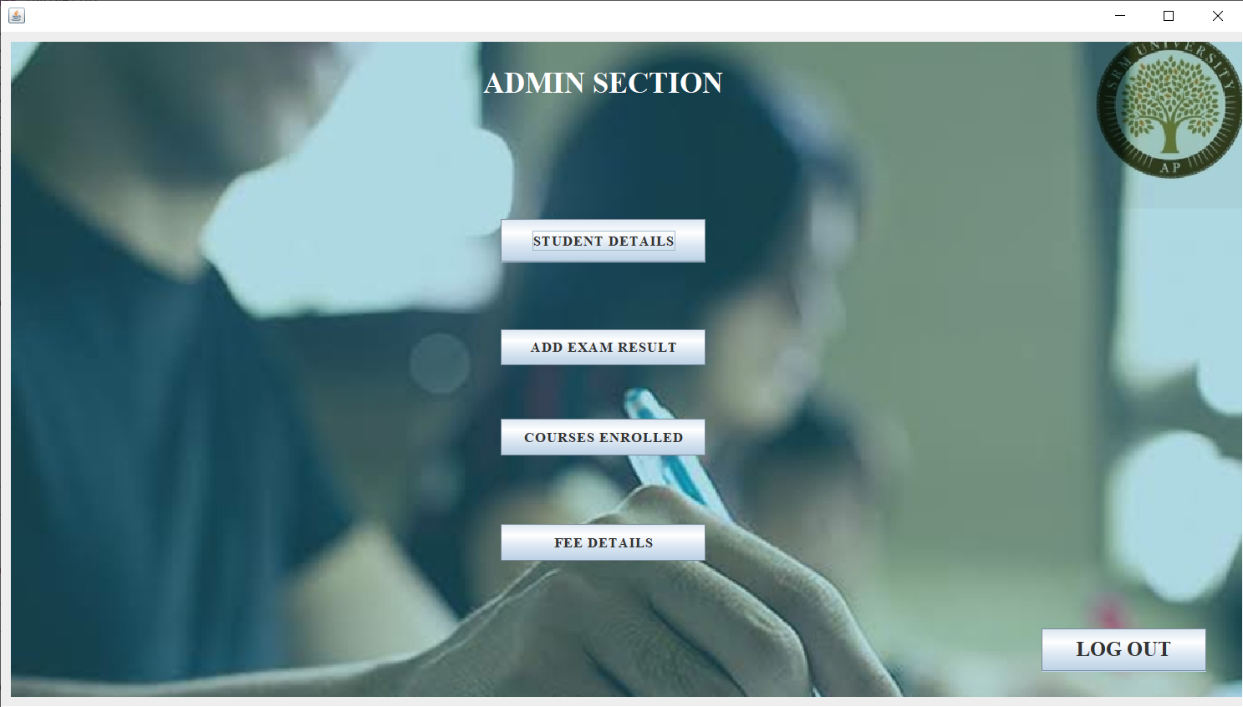

#### **6. STUDENT DETAILS**

##### **CODE:**

package loginfile;

import java.awt.EventQueue;

import javax.swing.JFrame;

import javax.swing.JPanel;

import javax.swing.border.EmptyBorder;

import javax.swing.JLabel;

import javax.swing.JOptionPane;

import java.awt.Font;

import javax.swing.JButton;

import java.awt.Color;

import java.awt.Component;

import javax.swing.JTextField;

import java.awt.event.ActionListener;

import java.awt.event.ActionEvent;

import java.sql.Connection;

import java.sql.DriverManager;

import java.sql.PreparedStatement;

import javax.swing.ImageIcon;

public class Studetailsadmin extends JFrame {

/**

*

*/

private static final long serialVersionUID = 1L;

private JPanel contentPane;

private JTextField T1;

private JTextField T2;

private JTextField T3;

private JTextField T7;

private JTextField T8;

private JTextField T4;

private JTextField T6;

protected Component frame;

/**

* Launch the application.

*/

public static void main(String[] args) {

EventQueue.invokeLater(new Runnable() {

public void run() {

try {

Studetailsadmin frame = new Studetailsadmin();

frame.setVisible(true);

} catch (Exception e) {

e.printStackTrace();

}

}

});

}

public Studetailsadmin() {

setDefaultCloseOperation(JFrame.EXIT_ON_CLOSE);

setBounds(100, 100, 1281, 749);

contentPane = new JPanel();

contentPane.setBorder(new EmptyBorder(5, 5, 5, 5));

setContentPane(contentPane);

contentPane.setLayout(null);

JLabel lblNewLabel = new JLabel("STUDENT PROFILE");

lblNewLabel.setFont(new Font("Times New Roman", Font.BOLD, 24));

lblNewLabel.setBounds(492, 52, 377, 18);

contentPane.add(lblNewLabel);

JLabel lblNewLabel_1 = new JLabel("Student Name");

lblNewLabel_1.setFont(new Font("Times New Roman", Font.BOLD, 14));

lblNewLabel_1.setBounds(115, 173, 96, 13);

contentPane.add(lblNewLabel_1);

JLabel lblNewLabel_2 = new JLabel("StudentID");

lblNewLabel_2.setBackground(new Color(240, 240, 240));

lblNewLabel_2.setFont(new Font("Times New Roman", Font.BOLD, 14));

lblNewLabel_2.setBounds(113, 261, 64, 13);

contentPane.add(lblNewLabel_2);

JLabel lblNewLabel_3 = new JLabel("Email");

lblNewLabel_3.setFont(new Font("Times New Roman", Font.BOLD, 14));

lblNewLabel_3.setBounds(115, 218, 46, 13);

contentPane.add(lblNewLabel_3);

JLabel lblNewLabel_4 = new JLabel("Section");

lblNewLabel_4.setFont(new Font("Times New Roman", Font.BOLD, 14));

lblNewLabel_4.setBounds(113, 306, 46, 13);

contentPane.add(lblNewLabel_4);

JLabel lblNewLabel_6 = new JLabel("Date of Birth");

lblNewLabel_6.setFont(new Font("Times New Roman", Font.BOLD, 14));

lblNewLabel_6.setBounds(115, 348, 96, 13);

contentPane.add(lblNewLabel_6);

JLabel lblNewLabel_7 = new JLabel("Gender");

lblNewLabel_7.setFont(new Font("Times New Roman", Font.BOLD, 14));

lblNewLabel_7.setBounds(115, 391, 46, 13);

contentPane.add(lblNewLabel_7);

JLabel lblNewLabel_8 = new JLabel("Phone");

lblNewLabel_8.setFont(new Font("Times New Roman", Font.BOLD, 14));

lblNewLabel_8.setBounds(115, 441, 46, 13);

contentPane.add(lblNewLabel_8);

JLabel lblNewLabel_9 = new JLabel("Address");

lblNewLabel_9.setFont(new Font("Times New Roman", Font.BOLD, 14));

lblNewLabel_9.setBounds(115, 486, 77, 13);

contentPane.add(lblNewLabel_9);

JButton btnNewButton = new JButton("BACK");

btnNewButton.addActionListener(new ActionListener() {

public void actionPerformed(ActionEvent e) {

Adminfile window = new Adminfile();

window.frame.setVisible(true);

}

});

btnNewButton.setFont(new Font("Times New Roman", Font.BOLD, 18));

btnNewButton.setBounds(1113, 640, 107, 38);

contentPane.add(btnNewButton);

T1 = new JTextField();

T1.setBounds(223, 171, 213, 19);

contentPane.add(T1);

T1.setColumns(10);

T2 = new JTextField();

T2.setBounds(223, 216, 213, 19);

contentPane.add(T2);

T2.setColumns(10);

T3 = new JTextField();

T3.setBounds(223, 261, 213, 19);

contentPane.add(T3);

T3.setColumns(10);

JTextField T5 = new JTextField();

T5.setBounds(223, 346, 213, 19);

contentPane.add(T5);

T5.setColumns(10);

T7 = new JTextField();

T7.setBounds(223, 439, 176, 19);

contentPane.add(T7);

T7.setColumns(10);

T8 = new JTextField();

T8.setBounds(223, 486, 213, 178);

contentPane.add(T8);

T8.setColumns(10);

JButton btnNewButton_1 = new JButton("ADD");

btnNewButton_1.addActionListener(new ActionListener() {

public void actionPerformed(ActionEvent e) {

/*

String a = T1.getText().toString();

String b = T2.getText().toString();

String c = T3.getText().toString();

String h = T4.getText().toString();

String i = T5.getText().toString();

String k = T6.getText().toString();

String l = T7.getText().toString();

String m = T8.getText().toString();

String n = T9.getText().toString();

@SuppressWarnings("deprecation")

String g = passwordField.getText().toString();

try {

File file = new File("C:\\users\\suhitha\\Desktop\\Studentdetailsadmin");

FileWriter fw= new FileWriter (file,true);

fw.write(a+"\n");

fw.write(b+"\n");

fw.write(c+"\n");

fw.write(h+"\n");

fw.write(i+"\n");

fw.write(k+"\n");

fw.write(l+"\n");

fw.write(m+"\n");

fw.write(n+"\n");

fw.write(g+"\n");

fw.write("------------------------\n");

fw.close();

JOptionPane.showMessageDialog(null,"you have successfully added the data");

System.exit(0);

} catch (Exception e2) {

// TODO: handle exception

JOptionPane.showMessageDialog(null,"Please enter all the information needed");

System.exit(0);

}

*/

try {

Class.forName("com.mysql.jdbc.Driver");

Connection con=DriverManager.getConnection("jdbc:mysql://localhost:3306/studentdatabase","root","");

PreparedStatement ps=con.prepareStatement("insert into student_details values(?,?,?,?,?,?,?,?)");

ps.setString(1, T1.getText());

ps.setString(2, T2.getText());

ps.setString(3, T3.getText());

ps.setString(4, T4.getText());

ps.setString(5, T5.getText());

ps.setString(6, T6.getText());

ps.setString(7, T7.getText());

ps.setString(8, T8.getText());

int x =ps.executeUpdate();

if(x>0) {

System.out.println("Details are successfully added");

JOptionPane.showMessageDialog(frame,"DETAILS ARE added");

}

else {

System.out.println("failed");

System.exit(0);

}

} catch (Exception e2) {

// TODO: handle exception

System.out.println(e2);

}

}

});

btnNewButton_1.setFont(new Font("Times New Roman", Font.BOLD, 18));

btnNewButton_1.setBounds(773, 247, 132, 38);

contentPane.add(btnNewButton_1);

JButton btnNewButton_2 = new JButton("UPDATE");

btnNewButton_2.addActionListener(new ActionListener() {

public void actionPerformed(ActionEvent e) {

try {

Class.forName("com.mysql.jdbc.Driver");

Connection con=DriverManager.getConnection("jdbc:mysql://localhost:3306/studentdatabase","root","");

String queryString="Update student_details set Name='"+T1.getText()+"' ,Section='"+T4.getText()+"' , Phone='"+T7.getText()+"' where Name= '"+T1.getText()+"' ";

PreparedStatement ps=con.prepareStatement(queryString);

int x =ps.executeUpdate();

if(x>0) {

System.out.println("Details are successfully updated");

JOptionPane.showMessageDialog(frame,"Details are updated");

}

else {

System.out.println("failed");

System.exit(0);

}

} catch (Exception e2) {

// TODO: handle exception

System.out.println(e2);

}

}

});

btnNewButton_2.setFont(new Font("Times New Roman", Font.BOLD, 18));

btnNewButton_2.setBounds(773, 377, 132, 38);

contentPane.add(btnNewButton_2);

JButton btnNewButton_3 = new JButton("DELETE");

btnNewButton_3.addActionListener(new ActionListener() {

public void actionPerformed(ActionEvent e) {

try {

Class.forName("com.mysql.jdbc.Driver");

Connection con=DriverManager.getConnection("jdbc:mysql://localhost:3306/studentdatabase","root","");

String queryString="delete from student_details where Name='"+T1.getText()+"' ";

PreparedStatement ps=con.prepareStatement(queryString);

int x =ps.executeUpdate();

if(x>0) {

System.out.println("Details are successfully deleted");

JOptionPane.showMessageDialog(frame,"DETAILS ARE DELETED");

}

else {

System.out.println("failed");

System.exit(0);

}

} catch (Exception e2) {

// TODO: handle exception

System.out.println(e2);

}

}

});

btnNewButton_3.setFont(new Font("Times New Roman", Font.BOLD, 18));

btnNewButton_3.setBounds(773, 506, 132, 38);

contentPane.add(btnNewButton_3);

T4 = new JTextField();

T4.setBounds(223, 304, 213, 19);

contentPane.add(T4);

T4.setColumns(10);

T6 = new JTextField();

T6.setBounds(223, 389, 176, 19);

contentPane.add(T6);

T6.setColumns(10);

JLabel lblNewLabel_11 = new JLabel("");

lblNewLabel_11.setIcon(new ImageIcon("C:\\Users\\suhitha\\Downloads\\Webp.net-resizeimage (2).jpg"));

lblNewLabel_11.setBounds(0, 10, 1257, 692);

contentPane.add(lblNewLabel_11);

}

}

#### **OUTPUT:**

#### STUDENT DETAILS

If the “STUDENT DETAILS” button is clicked in the “ADMIN HOME PAGE”, then the page directs to the “STUDENT PROFILE” page where admin can “ADD/UPDATE/DELETE” student details and all the details are stored into the database, and if “BACK” button is pressed page redirects to the “ADMIN HOMEPAGE”.

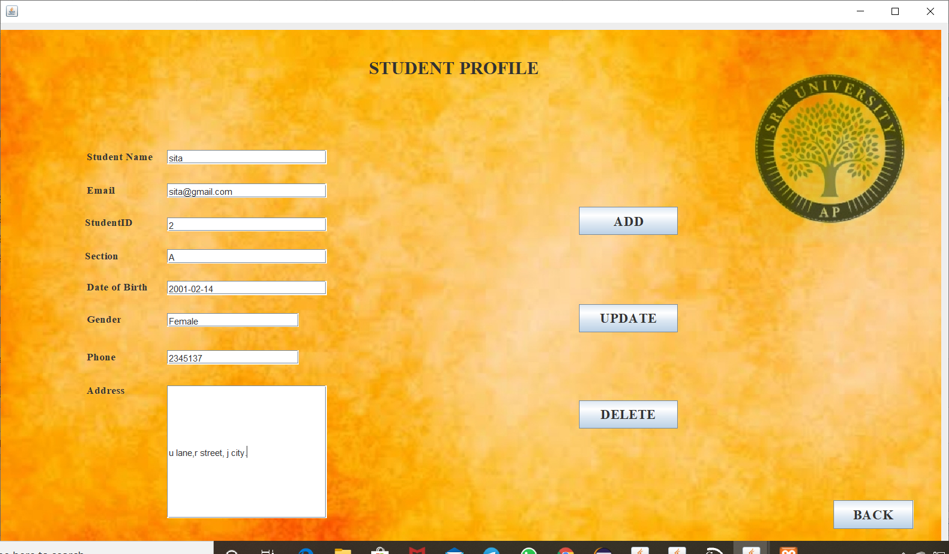

Whenever data is “ADDED/UPDATED/DELETED” we do get alert messages as follows:

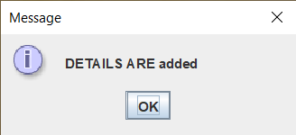

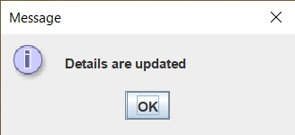

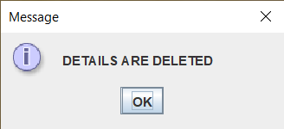

#### **7. EXAM RESULT**

##### **CODE:**

package loginfile;

import java.awt.EventQueue;

import javax.swing.JFrame;

import javax.swing.JPanel;

import javax.swing.border.EmptyBorder;

import javax.swing.JLabel;

import javax.swing.JOptionPane;

import java.awt.Font;

import javax.swing.JTextField;

import javax.swing.JButton;

import java.awt.event.ActionListener;

import java.sql.Connection;

import java.sql.DriverManager;

import java.sql.PreparedStatement;

import java.sql.ResultSet;

import java.awt.event.ActionEvent;

import javax.swing.ImageIcon;

import java.awt.Color;

public class Exammarksviewstu extends JFrame {

private static final long serialVersionUID = 1L;

private JPanel contentPane;

private JTextField T1;

private JTextField T3;

private JTextField T4;

private JTextField T5;

private JTextField T6;

private JTextField T7;

private JTextField T8;

private JTextField T9;

/**

* Launch the application.

*/

public static void main(String[] args) {

EventQueue.invokeLater(new Runnable() {

public void run() {

try {

Exammarksviewstu frame = new Exammarksviewstu ();

frame.setVisible(true);

} catch (Exception e) {

e.printStackTrace();

}

}

});

}

/**

* Create the frame.

*/

public Exammarksviewstu () {

setDefaultCloseOperation(JFrame.EXIT_ON_CLOSE);

setBounds(100, 100, 1176, 683);

contentPane = new JPanel();

contentPane.setBorder(new EmptyBorder(5, 5, 5, 5));

setContentPane(contentPane);

contentPane.setLayout(null);

JLabel lblNewLabel = new JLabel("EXAM MARKS DETAILS");

lblNewLabel.setFont(new Font("Times New Roman", Font.BOLD, 22));

lblNewLabel.setBounds(442, 69, 287, 26);

contentPane.add(lblNewLabel);

JLabel lblNewLabel_1 = new JLabel("Name");

lblNewLabel_1.setFont(new Font("Times New Roman", Font.BOLD, 14));

lblNewLabel_1.setBounds(79, 141, 104, 13);

contentPane.add(lblNewLabel_1);

JLabel lblNewLabel_3 = new JLabel("Subject wise marks");

lblNewLabel_3.setFont(new Font("Times New Roman", Font.BOLD, 27));

lblNewLabel_3.setBounds(447, 212, 322, 35);

contentPane.add(lblNewLabel_3);

T1 = new JTextField();

T1.setBounds(188, 139, 159, 19);

contentPane.add(T1);

T1.setColumns(10);

JLabel lblNewLabel_4 = new JLabel("CDC");

lblNewLabel_4.setFont(new Font("Times New Roman", Font.BOLD, 14));

lblNewLabel_4.setBounds(131, 311, 71, 13);

contentPane.add(lblNewLabel_4);

T3 = new JTextField();

T3.setBounds(226, 309, 96, 19);

contentPane.add(T3);

T3.setColumns(10);

JLabel lblNewLabel_5 = new JLabel("WT");

lblNewLabel_5.setFont(new Font("Times New Roman", Font.BOLD, 14));

lblNewLabel_5.setBounds(131, 378, 46, 13);

contentPane.add(lblNewLabel_5);

T4 = new JTextField();

T4.setBounds(226, 376, 96, 19);

contentPane.add(T4);

T4.setColumns(10);

JLabel lblNewLabel_6 = new JLabel("DM");

lblNewLabel_6.setFont(new Font("Times New Roman", Font.BOLD, 14));

lblNewLabel_6.setBounds(131, 441, 46, 13);

contentPane.add(lblNewLabel_6);

T5 = new JTextField();

T5.setBounds(226, 435, 96, 19);

contentPane.add(T5);

T5.setColumns(10);

JLabel lblNewLabel_7 = new JLabel("OOP");

lblNewLabel_7.setFont(new Font("Times New Roman", Font.BOLD, 14));

lblNewLabel_7.setBounds(731, 311, 46, 13);

contentPane.add(lblNewLabel_7);

T6 = new JTextField();

T6.setBounds(836, 309, 96, 19);

contentPane.add(T6);

T6.setColumns(10);

JLabel lblNewLabel_8 = new JLabel("FLAT");

lblNewLabel_8.setFont(new Font("Times New Roman", Font.BOLD, 14));

lblNewLabel_8.setBounds(731, 378, 46, 13);

contentPane.add(lblNewLabel_8);

T7 = new JTextField();

T7.setBounds(836, 376, 96, 19);

contentPane.add(T7);

T7.setColumns(10);

JLabel lblNewLabel_9 = new JLabel("COA");

lblNewLabel_9.setFont(new Font("Times New Roman", Font.BOLD, 14));

lblNewLabel_9.setBounds(731, 441, 46, 13);

contentPane.add(lblNewLabel_9);

T8 = new JTextField();

T8.setBounds(836, 439, 96, 19);

contentPane.add(T8);

T8.setColumns(10);

JButton btnNewButton_1 = new JButton("BACK");

btnNewButton_1.setBackground(new Color(0, 255, 255));

btnNewButton_1.addActionListener(new ActionListener() {

public void actionPerformed(ActionEvent e) {

Studentpage window = new Studentpage();

window.frame.setVisible(true);

}

});

btnNewButton_1.setFont(new Font("Times New Roman", Font.BOLD, 18));

btnNewButton_1.setBounds(44, 589, 104, 35);

contentPane.add(btnNewButton_1);

JButton btnNewButton = new JButton("SEARCH");

btnNewButton.setBackground(Color.PINK);

btnNewButton.addActionListener(new ActionListener() {

public void actionPerformed(ActionEvent e) {

Function f=new Function();

ResultSet rs=null;

rs=f.find(T1.getText());

try {

if(rs.next()) {

T3.setText(rs.getString("CDC"));

T4.setText(rs.getString("WT"));

T5.setText(rs.getString("DM"));

T6.setText(rs.getString("OOPS"));

T7.setText(rs.getString("FLAT"));

T8.setText(rs.getString("COA"));

double[]R=new double[10];

R[0]=Double.parseDouble(T3.getText());

R[1]=Double.parseDouble(T4.getText());

R[2]=Double.parseDouble(T5.getText());

R[3]=Double.parseDouble(T6.getText());

R[4]=Double.parseDouble(T7.getText());

R[5]=Double.parseDouble(T8.getText());

R[6]=(R[0]+R[1]+R[2]+R[3]+R[3]+R[4]+R[5]);

String TOTAL=String.format("%.0f", R[6]);

T9.setText(TOTAL);

}

else {

JOptionPane.showMessageDialog(null,"No data for this Student Name");

}

}catch(Exception e2){

JOptionPane.showMessageDialog(null,e2.getMessage());

}

}

class Function{

ResultSet rs=null;

public ResultSet find(String s) {

try {

Class.forName("com.mysql.jdbc.Driver");

Connection con=DriverManager.getConnection("jdbc:mysql://localhost:3306/studentdatabase","root","");

PreparedStatement ps=con.prepareStatement("select * from exam_details where Name =?" );

ps.setString(1, s);

rs=ps.executeQuery();

/*while(rs.next()) {

String nameString=rs.getString("Student Name");

String cdcString=rs.getString("CDC");

String wtString=rs.getString("WT");

String dmString=rs.getString("DM");

String oopsString=rs.getString("OOPS");

String flatString=rs.getString("FLAT");

String coaString=rs.getString("COA");

System.out.println(nameString+" "+cdcString+" "+wtString+" "+dmString+" "+oopsString+" "+flatString+" "+coaString);

}

*/

} catch (Exception e2) {

// TODO: handle exception

System.out.println(e2);

}

return rs;

}

}

});

btnNewButton.setFont(new Font("Times New Roman", Font.BOLD, 18));

btnNewButton.setBounds(118, 193, 137, 26);

contentPane.add(btnNewButton);

JLabel lblNewLabel_2 = new JLabel("TOTAL");

lblNewLabel_2.setFont(new Font("Times New Roman", Font.BOLD, 16));

lblNewLabel_2.setBounds(467, 509, 71, 13);

contentPane.add(lblNewLabel_2);

T9 = new JTextField();

T9.setBounds(586, 507, 96, 19);

contentPane.add(T9);

T9.setColumns(10);

JLabel lblNewLabel_10 = new JLabel("");

lblNewLabel_10.setIcon(new ImageIcon("C:\\Users\\suhitha\\Downloads\\Webp.net-resizeimage (7).jpg"));

lblNewLabel_10.setBounds(0, 10, 1205, 626);

contentPane.add(lblNewLabel_10);

}

}

#### **OUTPUT:**

#### ADD EXAM RESULT

If the “ADD EXAM RESULT” button is clicked in the “ADMIN HOME PAGE”, then the page directs to the “EXAM MARKS DETAILS” page where admin can “ADD/RESET” exam marks details and all the details are stored into the database, and if “BACK” button is pressed page redirects to the “ADMIN HOMEPAGE”.

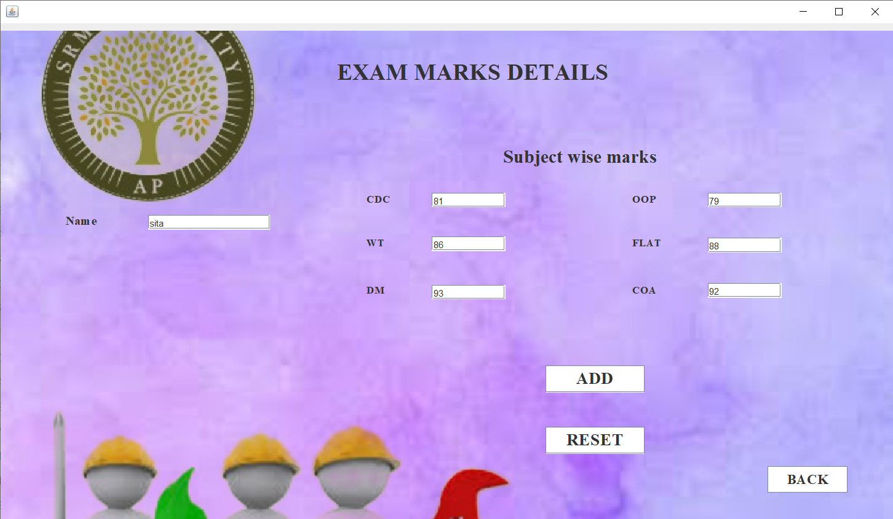

Whenever data is “ADDED” we do get the alert message as follows:

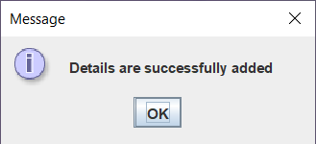

#### **8. COURSES ENROLLED**

##### **CODE:**

package loginfile;

import java.awt.EventQueue;

import javax.swing.JFrame;

import javax.swing.JPanel;

import javax.swing.border.EmptyBorder;

import javax.swing.JLabel;

import java.awt.Font;

import javax.swing.JButton;

import java.awt.event.ActionListener;

import java.awt.event.ActionEvent;

import javax.swing.ImageIcon;

import java.awt.Color;

public class Coursesenrolledadmin extends JFrame {

private static final long serialVersionUID = 1L;

private JPanel contentPane;

/**

* Launch the application.

*/

public static void main(String[] args) {

EventQueue.invokeLater(new Runnable() {

public void run() {

try {

Coursesenrolledadmin frame = new Coursesenrolledadmin();

frame.setVisible(true);

} catch (Exception e) {

e.printStackTrace();

}

}

});

}

/**

* Create the frame.

*/

public Coursesenrolledadmin() {

setDefaultCloseOperation(JFrame.EXIT_ON_CLOSE);

setBounds(100, 100, 1113, 706);

contentPane = new JPanel();

contentPane.setBorder(new EmptyBorder(5, 5, 5, 5));

setContentPane(contentPane);

contentPane.setLayout(null);

JLabel lblNewLabel = new JLabel("STUDENT WISE SUBJECTS");

lblNewLabel.setFont(new Font("Times New Roman", Font.BOLD, 24));

lblNewLabel.setBounds(386, 34, 373, 29);

contentPane.add(lblNewLabel);

JLabel lblNewLabel_1 = new JLabel("S.NO");

lblNewLabel_1.setFont(new Font("Times New Roman", Font.BOLD, 18));

lblNewLabel_1.setBounds(267, 139, 61, 21);

contentPane.add(lblNewLabel_1);

JLabel lblNewLabel_2 = new JLabel("CODE");

lblNewLabel_2.setForeground(Color.WHITE);

lblNewLabel_2.setFont(new Font("Times New Roman", Font.BOLD, 18));

lblNewLabel_2.setBounds(401, 142, 75, 15);

contentPane.add(lblNewLabel_2);

JLabel lblNewLabel_3 = new JLabel("SUBJECT NAME");

lblNewLabel_3.setFont(new Font("Times New Roman", Font.BOLD, 18));

lblNewLabel_3.setBounds(563, 139, 155, 21);

contentPane.add(lblNewLabel_3);

JLabel lblNewLabel_4 = new JLabel("CREDITS");

lblNewLabel_4.setForeground(Color.WHITE);

lblNewLabel_4.setFont(new Font("Times New Roman", Font.BOLD, 18));

lblNewLabel_4.setBounds(773, 136, 98, 27);

contentPane.add(lblNewLabel_4);

JLabel lblNewLabel_5 = new JLabel("1.");

lblNewLabel_5.setFont(new Font("Times New Roman", Font.PLAIN, 16));

lblNewLabel_5.setBounds(282, 206, 46, 13);

contentPane.add(lblNewLabel_5);

JLabel lblNewLabel_6 = new JLabel("2.");

lblNewLabel_6.setFont(new Font("Times New Roman", Font.PLAIN, 16));

lblNewLabel_6.setBounds(282, 282, 46, 13);

contentPane.add(lblNewLabel_6);

JLabel lblNewLabel_7 = new JLabel("3.");

lblNewLabel_7.setFont(new Font("Times New Roman", Font.PLAIN, 16));

lblNewLabel_7.setBounds(282, 348, 46, 13);

contentPane.add(lblNewLabel_7);

JLabel lblNewLabel_8 = new JLabel("4.");

lblNewLabel_8.setFont(new Font("Times New Roman", Font.PLAIN, 16));

lblNewLabel_8.setBounds(282, 416, 46, 13);

contentPane.add(lblNewLabel_8);

JLabel lblNewLabel_9 = new JLabel("5.");

lblNewLabel_9.setFont(new Font("Times New Roman", Font.PLAIN, 16));

lblNewLabel_9.setBounds(282, 484, 46, 13);

contentPane.add(lblNewLabel_9);

JLabel lblNewLabel_10 = new JLabel("6.");

lblNewLabel_10.setFont(new Font("Times New Roman", Font.PLAIN, 16));

lblNewLabel_10.setBounds(282, 546, 46, 13);

contentPane.add(lblNewLabel_10);

JButton btnNewButton = new JButton("BACK");

btnNewButton.addActionListener(new ActionListener() {

public void actionPerformed(ActionEvent e) {

Adminfile window = new Adminfile();

window.frame.setVisible(true);

}

});

btnNewButton.setFont(new Font("Times New Roman", Font.BOLD, 18));

btnNewButton.setBounds(26, 619, 98, 29);

contentPane.add(btnNewButton);

JLabel lblNewLabel_11 = new JLabel("CDC-\r\n204");

lblNewLabel_11.setForeground(Color.WHITE);

lblNewLabel_11.setFont(new Font("Times New Roman", Font.PLAIN, 16));

lblNewLabel_11.setBounds(401, 206, 75, 13);

contentPane.add(lblNewLabel_11);

JLabel lblNewLabel_12 = new JLabel("CDC");

lblNewLabel_12.setFont(new Font("Times New Roman", Font.PLAIN, 14));

lblNewLabel_12.setBounds(610, 195, 134, 35);

contentPane.add(lblNewLabel_12);

JLabel lblNewLabel_13 = new JLabel("1");

lblNewLabel_13.setForeground(Color.WHITE);

lblNewLabel_13.setFont(new Font("Times New Roman", Font.PLAIN, 16));

lblNewLabel_13.setBounds(811, 206, 46, 13);

contentPane.add(lblNewLabel_13);

JLabel lblNewLabel_14 = new JLabel("CSE-202");

lblNewLabel_14.setForeground(Color.WHITE);

lblNewLabel_14.setFont(new Font("Times New Roman", Font.PLAIN, 16));

lblNewLabel_14.setBounds(401, 282, 75, 13);

contentPane.add(lblNewLabel_14);

JLabel lblNewLabel_15 = new JLabel("MAT-141");

lblNewLabel_15.setForeground(Color.WHITE);

lblNewLabel_15.setFont(new Font("Times New Roman", Font.PLAIN, 16));

lblNewLabel_15.setBounds(401, 348, 75, 13);

contentPane.add(lblNewLabel_15);

JLabel lblNewLabel_16 = new JLabel("CSE-205");

lblNewLabel_16.setForeground(Color.WHITE);

lblNewLabel_16.setFont(new Font("Times New Roman", Font.PLAIN, 16));

lblNewLabel_16.setBounds(401, 417, 75, 13);

contentPane.add(lblNewLabel_16);

JLabel lblNewLabel_17 = new JLabel("CSE-203");

lblNewLabel_17.setForeground(Color.WHITE);

lblNewLabel_17.setFont(new Font("Times New Roman", Font.PLAIN, 16));

lblNewLabel_17.setBounds(401, 485, 75, 13);

contentPane.add(lblNewLabel_17);

JLabel lblNewLabel_18 = new JLabel("CSE-204");

lblNewLabel_18.setForeground(Color.WHITE);

lblNewLabel_18.setFont(new Font("Times New Roman", Font.PLAIN, 16));

lblNewLabel_18.setBounds(401, 547, 67, 13);

contentPane.add(lblNewLabel_18);

JLabel lblNewLabel_19 = new JLabel("WT");

lblNewLabel_19.setFont(new Font("Times New Roman", Font.PLAIN, 14));

lblNewLabel_19.setBounds(610, 282, 98, 13);

contentPane.add(lblNewLabel_19);

JLabel lblNewLabel_20 = new JLabel("DM");

lblNewLabel_20.setFont(new Font("Times New Roman", Font.PLAIN, 14));

lblNewLabel_20.setBounds(610, 348, 46, 13);

contentPane.add(lblNewLabel_20);

JLabel lblNewLabel_21 = new JLabel("OOP");

lblNewLabel_21.setFont(new Font("Times New Roman", Font.PLAIN, 14));

lblNewLabel_21.setBounds(610, 417, 46, 13);

contentPane.add(lblNewLabel_21);

JLabel lblNewLabel_22 = new JLabel("FLAT");

lblNewLabel_22.setFont(new Font("Times New Roman", Font.PLAIN, 14));

lblNewLabel_22.setBounds(610, 485, 46, 13);

contentPane.add(lblNewLabel_22);

JLabel lblNewLabel_23 = new JLabel("COA");

lblNewLabel_23.setFont(new Font("Times New Roman", Font.PLAIN, 14));

lblNewLabel_23.setBounds(610, 547, 46, 13);

contentPane.add(lblNewLabel_23);

JLabel lblNewLabel_24 = new JLabel("4");

lblNewLabel_24.setForeground(Color.WHITE);

lblNewLabel_24.setFont(new Font("Times New Roman", Font.PLAIN, 16));

lblNewLabel_24.setBounds(811, 282, 46, 13);

contentPane.add(lblNewLabel_24);

JLabel lblNewLabel_25 = new JLabel("3");

lblNewLabel_25.setForeground(Color.WHITE);

lblNewLabel_25.setFont(new Font("Times New Roman", Font.PLAIN, 16));

lblNewLabel_25.setBounds(811, 348, 46, 13);

contentPane.add(lblNewLabel_25);

JLabel lblNewLabel_26 = new JLabel("4");

lblNewLabel_26.setForeground(Color.WHITE);

lblNewLabel_26.setFont(new Font("Times New Roman", Font.PLAIN, 16));

lblNewLabel_26.setBounds(811, 417, 76, 13);

contentPane.add(lblNewLabel_26);

JLabel lblNewLabel_27 = new JLabel("3");

lblNewLabel_27.setForeground(Color.WHITE);

lblNewLabel_27.setFont(new Font("Times New Roman", Font.PLAIN, 16));

lblNewLabel_27.setBounds(811, 484, 46, 13);

contentPane.add(lblNewLabel_27);

JLabel lblNewLabel_28 = new JLabel("4");

lblNewLabel_28.setForeground(Color.WHITE);

lblNewLabel_28.setFont(new Font("Times New Roman", Font.PLAIN, 16));

lblNewLabel_28.setBounds(811, 546, 46, 13);

contentPane.add(lblNewLabel_28);

JLabel lblNewLabel_29 = new JLabel("");

lblNewLabel_29.setIcon(new ImageIcon("C:\\Users\\suhitha\\Desktop\\WhatsApp Image 2020-04-26 at 4.31.13 PM.jpeg"));

lblNewLabel_29.setBounds(10, 10, 1080, 677);

contentPane.add(lblNewLabel_29);

}

}

#### **OUTPUT:**

#### COURSES ENROLLED

If “COURSES ENROLLED” button is clicked in the “ADMIN HOME PAGE”, then the page directs to the “STUDENT WISE SUBJECTS” page and admin can view the courses enrolled details and if “BACK” button is clicked then the page redirects to the “ADMIN HOME PAGE”.

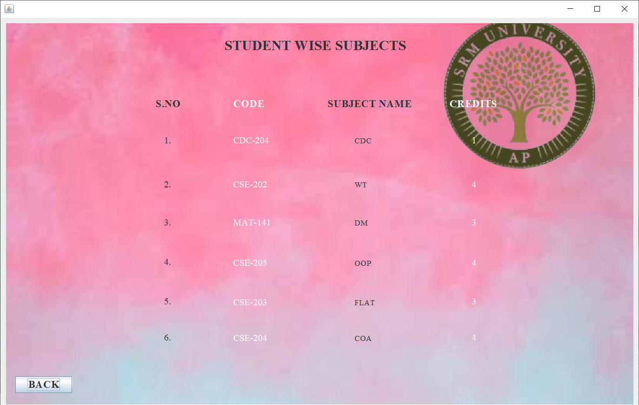

#### **9. FEE DETAILS**

##### **CODE:**

package loginfile;

import java.awt.Component;

//import java.awt.BorderLayout;

import java.awt.EventQueue;

import javax.swing.JFrame;

import javax.swing.JPanel;

import javax.swing.border.EmptyBorder;

import javax.swing.JLabel;

import javax.swing.JOptionPane;

import java.awt.Font;

import javax.swing.JTextField;

import javax.swing.JButton;

import javax.swing.ImageIcon;

import java.awt.event.ActionListener;

import java.sql.Connection;

import java.sql.DriverManager;

import java.sql.PreparedStatement;

import java.awt.event.ActionEvent;

public class Feedetailsadmin extends JFrame {

/**

*

*/

private static final long serialVersionUID = 1L;

private JPanel contentPane;

private JTextField T1;

private JTextField T2;

private JTextField T3;

private JTextField T4;

private JTextField T5;

/**

* Launch the application.

*/

public static void main(String[] args) {

EventQueue.invokeLater(new Runnable() {

public void run() {

try {

Feedetailsadmin frame = new Feedetailsadmin();

frame.setVisible(true);

} catch (Exception e) {

e.printStackTrace();

}

}

});

}

/**

* Create the frame.

*/

public Feedetailsadmin() {

setDefaultCloseOperation(JFrame.EXIT_ON_CLOSE);

setBounds(100, 100, 1245, 717);

contentPane = new JPanel();

contentPane.setBorder(new EmptyBorder(5, 5, 5, 5));

setContentPane(contentPane);

contentPane.setLayout(null);

JLabel lblNewLabel = new JLabel("FEE DETAILS");

lblNewLabel.setFont(new Font("Times New Roman", Font.BOLD, 24));

lblNewLabel.setBounds(523, 50, 197, 21);

contentPane.add(lblNewLabel);

JLabel lblNewLabel_1 = new JLabel("Name");

lblNewLabel_1.setFont(new Font("Times New Roman", Font.BOLD, 16));

lblNewLabel_1.setBounds(114, 172, 46, 13);

contentPane.add(lblNewLabel_1);

JLabel lblNewLabel_2 = new JLabel("StudentID");

lblNewLabel_2.setFont(new Font("Times New Roman", Font.BOLD, 16));

lblNewLabel_2.setBounds(114, 237, 90, 13);

contentPane.add(lblNewLabel_2);

JLabel lblNewLabel_3 = new JLabel("Section");

lblNewLabel_3.setFont(new Font("Times New Roman", Font.BOLD, 16));

lblNewLabel_3.setBounds(114, 301, 90, 13);

contentPane.add(lblNewLabel_3);

JLabel lblNewLabel_4 = new JLabel("Fee paid");

lblNewLabel_4.setFont(new Font("Times New Roman", Font.BOLD, 16));

lblNewLabel_4.setBounds(114, 368, 90, 13);

contentPane.add(lblNewLabel_4);

JLabel lblNewLabel_5 = new JLabel("Fee due");

lblNewLabel_5.setFont(new Font("Times New Roman", Font.BOLD, 16));

lblNewLabel_5.setBounds(114, 439, 90, 13);

contentPane.add(lblNewLabel_5);

T1 = new JTextField();

T1.setBounds(228, 170, 166, 21);

contentPane.add(T1);

T1.setColumns(10);

T2 = new JTextField();

T2.setBounds(228, 234, 166, 21);

contentPane.add(T2);

T2.setColumns(10);

T3 = new JTextField();

T3.setBounds(228, 299, 166, 19);

contentPane.add(T3);

T3.setColumns(10);

T4 = new JTextField();

T4.setBounds(228, 366, 166, 19);

contentPane.add(T4);

T4.setColumns(10);

T5 = new JTextField();

T5.setBounds(228, 437, 166, 19);

contentPane.add(T5);

T5.setColumns(10);

JButton btnNewButton = new JButton("ADD");

btnNewButton.addActionListener(new ActionListener() {

private Component frame;

public void actionPerformed(ActionEvent e) {

try {

Class.forName("com.mysql.jdbc.Driver");

Connection con=DriverManager.getConnection("jdbc:mysql://localhost:3306/studentdatabase","root","");

PreparedStatement ps=con.prepareStatement("insert into fee_details values(?,?,?,?,?)");

ps.setString(1, T1.getText());

ps.setString(2, T2.getText());

ps.setString(3, T3.getText());

ps.setString(4, T4.getText());

ps.setString(5, T5.getText());

int x =ps.executeUpdate();

if(x>0) {

System.out.println("Details are successfully added");

JOptionPane.showMessageDialog(frame,"Details are successfully added");

}

else {

System.out.println("failed");

System.exit(0);

}

} catch (Exception e2) {

// TODO: handle exception

System.out.println(e2);

}

}

});

btnNewButton.setFont(new Font("Times New Roman", Font.BOLD, 18));

btnNewButton.setBounds(722, 198, 117, 33);

contentPane.add(btnNewButton);

JButton btnNewButton_1 = new JButton("UPDATE");

btnNewButton_1.addActionListener(new ActionListener() {

private Component frame;

public void actionPerformed(ActionEvent e) {

try {

Class.forName("com.mysql.jdbc.Driver");

Connection con=DriverManager.getConnection("jdbc:mysql://localhost:3306/studentdatabase","root","");

String queryString="Update fee_details set Name='"+T1.getText()+"' ,Fee paid='"+T4.getText()+"' , Fee due='"+T5.getText()+"' where Name= '"+T1.getText()+"' ";

PreparedStatement ps=con.prepareStatement(queryString);

int x =ps.executeUpdate();

if(x>0) {

System.out.println("Details are successfully updated");

JOptionPane.showMessageDialog(frame,"Details are updated");

}

else {

System.out.println("failed");

System.exit(0);

}

} catch (Exception e2) {

// TODO: handle exception

System.out.println(e2);

}

}

});

btnNewButton_1.setFont(new Font("Times New Roman", Font.BOLD, 18));

btnNewButton_1.setBounds(722, 304, 117, 33);

contentPane.add(btnNewButton_1);

JButton btnNewButton_2 = new JButton("DELETE");

btnNewButton_2.addActionListener(new ActionListener() {

private Component frame;

public void actionPerformed(ActionEvent e) {

try {

Class.forName("com.mysql.jdbc.Driver");

Connection con=DriverManager.getConnection("jdbc:mysql://localhost:3306/studentdatabase","root","");

String queryString="delete from fee_details where Name='"+T1.getText()+"' ";

PreparedStatement ps=con.prepareStatement(queryString);

int x =ps.executeUpdate();

if(x>0) {

System.out.println("Details are successfully deleted");

JOptionPane.showMessageDialog(frame,"DETAILS ARE DELETED");

}

else {

System.out.println("failed");

System.exit(0);

}

} catch (Exception e2) {

// TODO: handle exception

System.out.println(e2);

}

}

});

btnNewButton_2.setFont(new Font("Times New Roman", Font.BOLD, 18));

btnNewButton_2.setBounds(722, 398, 117, 33);

contentPane.add(btnNewButton_2);

JButton btnNewButton_3 = new JButton("BACK");

btnNewButton_3.addActionListener(new ActionListener() {

public void actionPerformed(ActionEvent e) {

Adminfile window = new Adminfile();

window.frame.setVisible(true);

}

});

btnNewButton_3.setFont(new Font("Times New Roman", Font.BOLD, 20));

btnNewButton_3.setBounds(1035, 593, 117, 33);

contentPane.add(btnNewButton_3);

JLabel lblNewLabel_6 = new JLabel("");

lblNewLabel_6.setIcon(new ImageIcon("C:\\Users\\suhitha\\Downloads\\Webp.net-resizeimage (4).jpg"));

lblNewLabel_6.setBounds(10, 10, 1221, 680);

contentPane.add(lblNewLabel_6);

}

}

#### **OUTPUT:**

#### FEE DETAILS

If “FEE DETAILS” button is clicked in the “ADMIN HOME PAGE”, then the page directs to the “FEE DETAILS” page where admin can “ADD/UPDATE/DELETE” the student fee details and if “BACK” button is clicked then the page redirects to the “ADMIN HOME PAGE”.

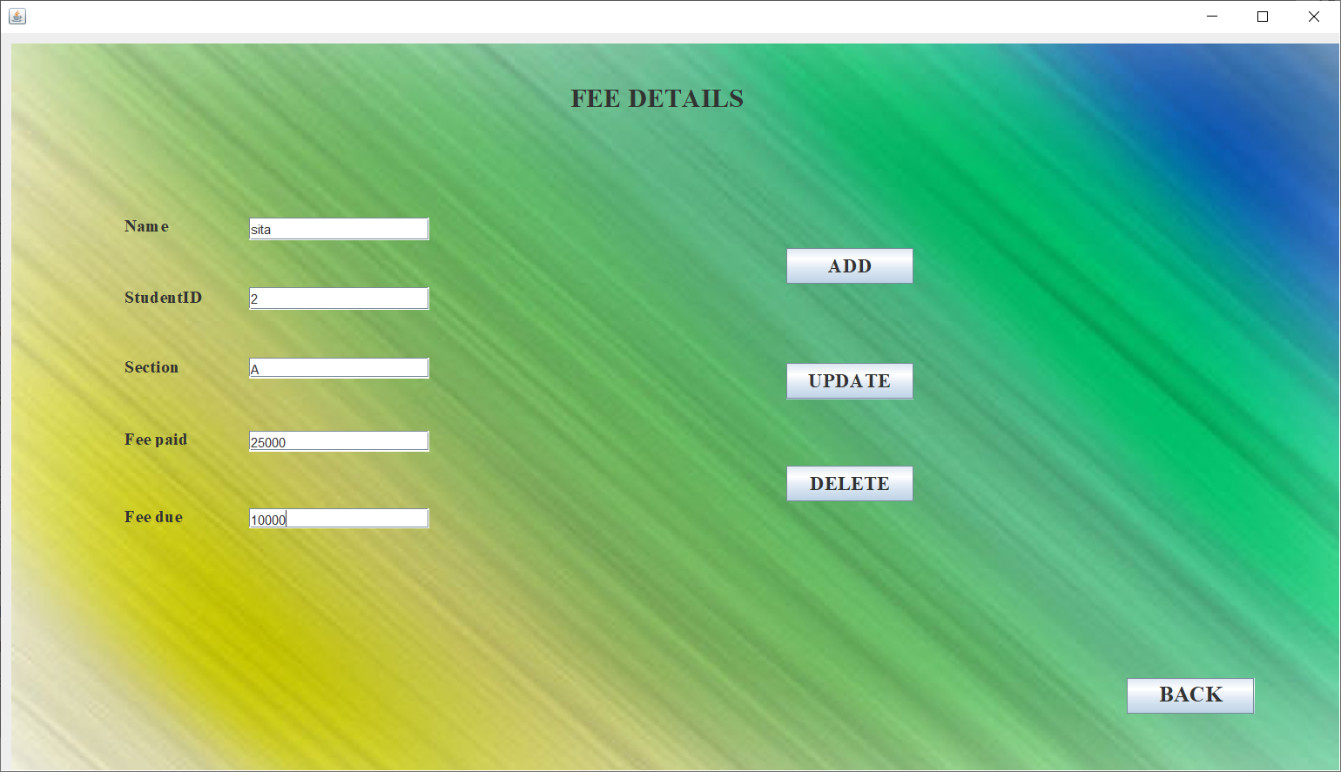

Whenever data is “ADDED/UPDATED/DELETED” we do get alert messages as follows:







This is all about the “ADMIN HOME PAGE”

#### **10. STUDENT LOGIN**

##### **CODE:**

package loginfile;

import java.awt.EventQueue;

import javax.swing.JFrame;

import javax.swing.JButton;

import java.awt.event.ActionListener;

import java.awt.event.ActionEvent;

import java.awt.Font;

import javax.swing.JLabel;

import javax.swing.ImageIcon;

public class Studentpage {

JFrame frame;

/**

* Launch the application.

*/

public static void main(String[] args) {

EventQueue.invokeLater(new Runnable() {

public void run() {

try {

Studentpage window = new Studentpage();

window.frame.setVisible(true);

} catch (Exception e) {

e.printStackTrace();

}

}

});

}

/**

* Create the application.

*/

public Studentpage() {

initialize();

}

/**

* Initialize the contents of the frame.

*/

private void initialize() {

frame = new JFrame();

frame.setBounds(100, 100, 1125, 747);

frame.setDefaultCloseOperation(JFrame.EXIT_ON_CLOSE);

frame.getContentPane().setLayout(null);

JButton btnNewButton_1 = new JButton("COURSES ENROLLED");

btnNewButton_1.addActionListener(new ActionListener() {

public void actionPerformed(ActionEvent e) {

Courseenrolledstu frame = new Courseenrolledstu();

frame.setVisible(true);

}

});

btnNewButton_1.setFont(new Font("Times New Roman", Font.BOLD, 18));

btnNewButton_1.setBounds(408, 289, 263, 35);

frame.getContentPane().add(btnNewButton_1);

JButton btnNewButton = new JButton("EXAM MARKSHEET");

btnNewButton.addActionListener(new ActionListener() {

public void actionPerformed(ActionEvent e) {

Exammarksviewstu frame = new Exammarksviewstu ();

frame.setVisible(true);

}

});

btnNewButton.setFont(new Font("Times New Roman", Font.BOLD, 18));

btnNewButton.setBounds(408, 387, 261, 35);

frame.getContentPane().add(btnNewButton);

JLabel lblNewLabel = new JLabel("STUDENT DASHBOARD");

lblNewLabel.setFont(new Font("Times New Roman", Font.BOLD, 24));

lblNewLabel.setBounds(408, 26, 315, 35);

frame.getContentPane().add(lblNewLabel);

JButton btnNewButton_4 = new JButton("VIEW PROFILE");

btnNewButton_4.addActionListener(new ActionListener() {

public void actionPerformed(ActionEvent e) {

Studentprofile frame = new Studentprofile();

frame.setVisible(true);

}

});

btnNewButton_4.setFont(new Font("Times New Roman", Font.BOLD, 18));

btnNewButton_4.setBounds(408, 195, 263, 35);

frame.getContentPane().add(btnNewButton_4);

JButton btnNewButton_5 = new JButton("LOG OUT");

btnNewButton_5.addActionListener(new ActionListener() {

public void actionPerformed(ActionEvent e) {

Loginfile window = new Loginfile();

window.frame.setVisible(true);

}

});

btnNewButton_5.setFont(new Font("Times New Roman", Font.BOLD, 16));

btnNewButton_5.setBounds(936, 642, 125, 32);

frame.getContentPane().add(btnNewButton_5);

JButton btnNewButton_2 = new JButton("FEE DETAILS");

btnNewButton_2.addActionListener(new ActionListener() {

public void actionPerformed(ActionEvent e) {

Feedetails_student frame = new Feedetails_student();

frame.setVisible(true);

}

});

btnNewButton_2.setFont(new Font("Times New Roman", Font.BOLD, 18));

btnNewButton_2.setBounds(408, 484, 263, 35);

frame.getContentPane().add(btnNewButton_2);

JLabel lblNewLabel_1 = new JLabel("");

lblNewLabel_1.setIcon(new ImageIcon("C:\\Users\\suhitha\\Desktop\\WhatsApp Image 2020-04-26 at 1.42.09 PM.jpeg"));

lblNewLabel_1.setBounds(10, 10, 1091, 690);

frame.getContentPane().add(lblNewLabel_1);

}

}

#### **OUTPUT:**

#### STUDENT LOGIN

If the user selects “STUDENT” radio button after entering the username and password in the “LOG IN FORM”, then the page directs to the “STUDENT DASHBOARD” and if “LOG OUT” button is clicked then page redirects to the “LOGIN FORM”.

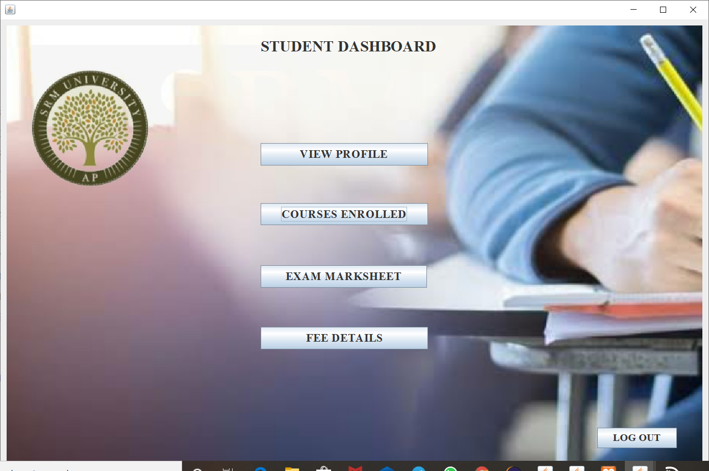

#### **11. VIEW PROFILE**

##### **CODE:**

package loginfile;

import java.awt.EventQueue;

import javax.swing.JFrame;

import javax.swing.JPanel;

import javax.swing.border.EmptyBorder;

import javax.swing.JLabel;

import javax.swing.JOptionPane;

import java.awt.Font;

import javax.swing.JButton;

import java.awt.Color;

import javax.swing.JTextField;

import java.awt.event.ActionListener;

import java.awt.event.ActionEvent;

import javax.swing.ImageIcon;

//import java.io.BufferedReader;

//import java.io.File;

//import java.io.FileWriter;

//import java.io.FileNotFoundException; // Import this class to handle errors

//import java.io.FileReader;

//import java.util.Scanner;

import java.sql.Connection;

import java.sql.DriverManager;

import java.sql.PreparedStatement;

import java.sql.ResultSet;

public class Studentprofile extends JFrame {

private static final long serialVersionUID = 1L;

private JPanel contentPane;

private JTextField T2;

private JTextField T3;

private JTextField T4;

private JTextField T6;

private JTextField T8;

private JTextField T9;

private JTextField T5;

private JTextField T7;

private JTextField T1;

/**

* Launch the application.

*/

public static void main(String[] args) {

EventQueue.invokeLater(new Runnable() {

public void run() {

try {

Studentprofile frame = new Studentprofile();

frame.setVisible(true);

} catch (Exception e) {

e.printStackTrace();

}

}

});

}

/**

* Create the frame.

*/

public Studentprofile() {

setDefaultCloseOperation(JFrame.EXIT_ON_CLOSE);

setBounds(100, 100, 1281, 749);

contentPane = new JPanel();

contentPane.setBorder(new EmptyBorder(5, 5, 5, 5));

setContentPane(contentPane);

contentPane.setLayout(null);

JLabel lblNewLabel = new JLabel("STUDENT PROFILE");

lblNewLabel.setFont(new Font("Times New Roman", Font.BOLD, 24));

lblNewLabel.setBounds(492, 27, 377, 18);

contentPane.add(lblNewLabel);

JLabel lblNewLabel_1 = new JLabel("Name");

lblNewLabel_1.setFont(new Font("Times New Roman", Font.BOLD, 14));

lblNewLabel_1.setBounds(446, 173, 96, 13);

contentPane.add(lblNewLabel_1);

JLabel lblNewLabel_2 = new JLabel("StudentID");

lblNewLabel_2.setBackground(new Color(240, 240, 240));

lblNewLabel_2.setFont(new Font("Times New Roman", Font.BOLD, 14));

lblNewLabel_2.setBounds(446, 263, 64, 13);

contentPane.add(lblNewLabel_2);

JLabel lblNewLabel_3 = new JLabel("Email");

lblNewLabel_3.setFont(new Font("Times New Roman", Font.BOLD, 14));

lblNewLabel_3.setBounds(446, 218, 46, 13);

contentPane.add(lblNewLabel_3);

JLabel lblNewLabel_4 = new JLabel("Section");

lblNewLabel_4.setFont(new Font("Times New Roman", Font.BOLD, 14));

lblNewLabel_4.setBounds(446, 306, 46, 13);

contentPane.add(lblNewLabel_4);

JLabel lblNewLabel_6 = new JLabel("Date of Birth");

lblNewLabel_6.setFont(new Font("Times New Roman", Font.BOLD, 14));

lblNewLabel_6.setBounds(446, 348, 96, 13);

contentPane.add(lblNewLabel_6);

JLabel lblNewLabel_7 = new JLabel("Gender");

lblNewLabel_7.setFont(new Font("Times New Roman", Font.BOLD, 14));

lblNewLabel_7.setBounds(446, 395, 46, 13);

contentPane.add(lblNewLabel_7);

JLabel lblNewLabel_8 = new JLabel("Phone");

lblNewLabel_8.setFont(new Font("Times New Roman", Font.BOLD, 14));

lblNewLabel_8.setBounds(446, 441, 46, 13);

contentPane.add(lblNewLabel_8);

JLabel lblNewLabel_9 = new JLabel("Address");

lblNewLabel_9.setFont(new Font("Times New Roman", Font.BOLD, 14));

lblNewLabel_9.setBounds(446, 486, 77, 13);

contentPane.add(lblNewLabel_9);

JButton btnNewButton = new JButton("BACK");

btnNewButton.addActionListener(new ActionListener() {

public void actionPerformed(ActionEvent e) {

Studentpage window = new Studentpage();

window.frame.setVisible(true);

}

});

btnNewButton.setFont(new Font("Times New Roman", Font.BOLD, 18));

btnNewButton.setBounds(1129, 647, 107, 38);

contentPane.add(btnNewButton);

T2 = new JTextField();

T2.setBounds(595, 171, 213, 19);

contentPane.add(T2);

T2.setColumns(10);

T3 = new JTextField();

T3.setBounds(595, 216, 213, 19);

contentPane.add(T3);

T3.setColumns(10);

T4 = new JTextField();

T4.setBounds(595, 257, 213, 19);

contentPane.add(T4);

T4.setColumns(10);

T6 = new JTextField();

T6.setBounds(595, 346, 213, 19);

contentPane.add(T6);

T6.setColumns(10);

T8 = new JTextField();

T8.setBounds(593, 439, 176, 19);

contentPane.add(T8);

T8.setColumns(10);

T9 = new JTextField();

T9.setBounds(595, 486, 213, 178);

contentPane.add(T9);

T9.setColumns(10);

T5 = new JTextField();

T5.setBounds(595, 304, 213, 19);

contentPane.add(T5);

T5.setColumns(10);

T7 = new JTextField();

T7.setBounds(595, 389, 174, 19);

contentPane.add(T7);

T7.setColumns(10);

JLabel lblNewLabel_5 = new JLabel("Name");

lblNewLabel_5.setFont(new Font("Times New Roman", Font.BOLD, 14));

lblNewLabel_5.setBounds(96, 532, 77, 13);

contentPane.add(lblNewLabel_5);

JLabel lblNewLabel_10 = new JLabel("");

lblNewLabel_10.setBounds(991, 98, 46, 13);

contentPane.add(lblNewLabel_10);

T1 = new JTextField();

T1.setBounds(183, 530, 107, 19);

contentPane.add(T1);

T1.setColumns(10);

JButton btnNewButton_1 = new JButton("SEARCH");

btnNewButton_1.addActionListener(new ActionListener() {

public void actionPerformed(ActionEvent e) {

Function f=new Function();

ResultSet rs=null;

rs=f.find(T1.getText());

try {

if(rs.next()) {

T2.setText(rs.getString("Name"));

T3.setText(rs.getString("Email"));

T4.setText(rs.getString("StudentID"));

T5.setText(rs.getString("Section"));

T6.setText(rs.getString("Date of birth"));

T7.setText(rs.getString("Gender"));

T8.setText(rs.getString("Phone"));

T9.setText(rs.getString("Address"));

}

else {

JOptionPane.showMessageDialog(null,"No data for this Name");

}

} catch (Exception e2) {

JOptionPane.showMessageDialog(null,e2.getMessage());

// TODO: handle exception

}

}

class Function{

ResultSet rs=null;

public ResultSet find(String s) {

try {

Class.forName("com.mysql.jdbc.Driver");

Connection con=DriverManager.getConnection("jdbc:mysql://localhost:3306/studentdatabase","root","");

PreparedStatement ps=con.prepareStatement("select * from student_details where Name=?");

ps.setString(1, s);

rs=ps.executeQuery();

} catch (Exception e2) {

// TODO: handle exception

System.out.println(e2);

}

return rs;

}

}

});

btnNewButton_1.setFont(new Font("Times New Roman", Font.BOLD, 15));

btnNewButton_1.setBounds(128, 590, 107, 27);

contentPane.add(btnNewButton_1);

JLabel lblNewLabel_11 = new JLabel("");

lblNewLabel_11.setBounds(570, 307, 46, 13);

contentPane.add(lblNewLabel_11);

JLabel label = new JLabel("");

label.setIcon(new ImageIcon("C:\\Users\\suhitha\\Desktop\\WhatsApp Image 2020-04-26 at 1.42.09 PM.jpeg"));

label.setBounds(10, 10, 1247, 715);

contentPane.add(label);

}

}

#### **OUTPUT:**

#### VIEW PROFILE

If “VIEW PROFILE” button is clicked in the “STUDENT DASHBOARD” page then the page directs to the “STUDENT PROFILE” page and then students need to enter his/her name and after clicking on “SEARCH” button then the student details are displayed and if “BACK” button is clicked then the page redirects to the “STUDENT DASHBOARD” page.

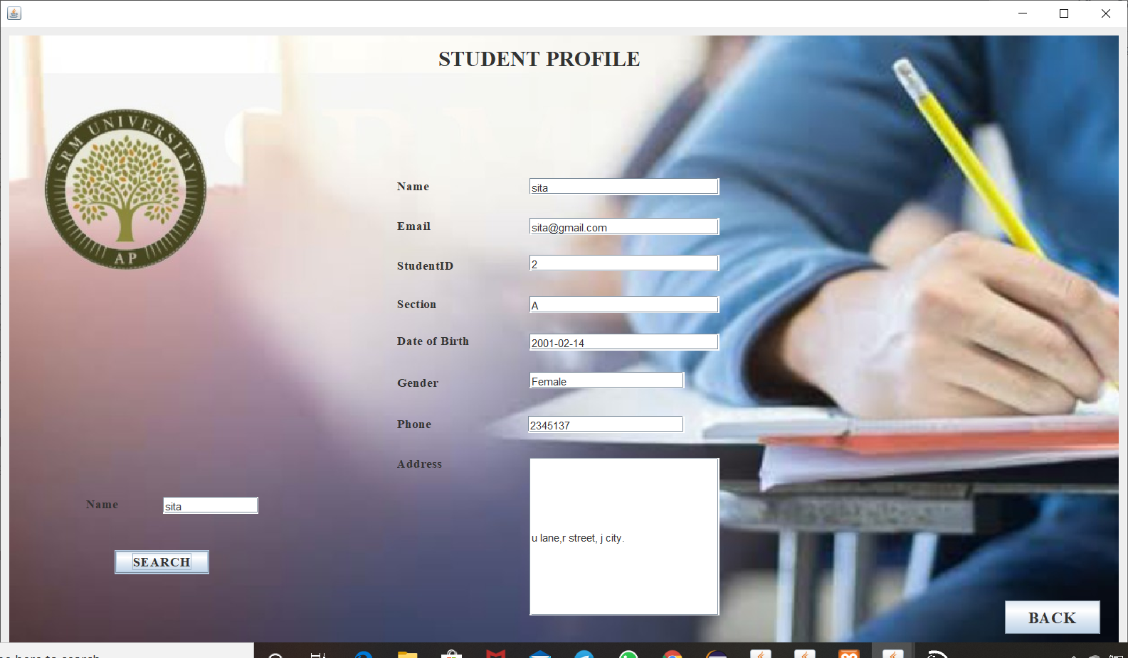

#### **12. VIEW COURSES ENROLLED**

##### **CODE:**

package loginfile;

import java.awt.EventQueue;

import javax.swing.JFrame;

import javax.swing.JPanel;

import javax.swing.border.EmptyBorder;

import javax.swing.JLabel;

import java.awt.Font;

import javax.swing.JButton;

import java.awt.event.ActionListener;

import java.awt.event.ActionEvent;

import javax.swing.ImageIcon;

import java.awt.Color;

public class Courseenrolledstu extends JFrame {

private static final long serialVersionUID = 1L;

private JPanel contentPane;

/**

* Launch the application.

*/

public static void main(String[] args) {

EventQueue.invokeLater(new Runnable() {

public void run() {

try {

Courseenrolledstu frame = new Courseenrolledstu();

frame.setVisible(true);

} catch (Exception e) {

e.printStackTrace();

}

}

});

}

/**

* Create the frame.

*/

public Courseenrolledstu() {

setDefaultCloseOperation(JFrame.EXIT_ON_CLOSE);

setBounds(100, 100, 1274, 706);

contentPane = new JPanel();

contentPane.setBorder(new EmptyBorder(5, 5, 5, 5));

setContentPane(contentPane);

contentPane.setLayout(null);

JLabel lblNewLabel = new JLabel("STUDENT WISE SUBJECTS");

lblNewLabel.setForeground(Color.WHITE);

lblNewLabel.setFont(new Font("Times New Roman", Font.BOLD, 24));

lblNewLabel.setBounds(486, 31, 373, 29);

contentPane.add(lblNewLabel);

JLabel lblNewLabel_1 = new JLabel("S.NO");

lblNewLabel_1.setFont(new Font("Times New Roman", Font.BOLD, 18));

lblNewLabel_1.setBounds(267, 139, 61, 21);

contentPane.add(lblNewLabel_1);

JLabel lblNewLabel_2 = new JLabel("CODE");

lblNewLabel_2.setFont(new Font("Times New Roman", Font.BOLD, 18));

lblNewLabel_2.setBounds(401, 142, 75, 15);

contentPane.add(lblNewLabel_2);

JLabel lblNewLabel_3 = new JLabel("SUBJECT NAME");

lblNewLabel_3.setFont(new Font("Times New Roman", Font.BOLD, 18));

lblNewLabel_3.setBounds(563, 139, 155, 21);

contentPane.add(lblNewLabel_3);

JLabel lblNewLabel_4 = new JLabel("CREDITS");

lblNewLabel_4.setFont(new Font("Times New Roman", Font.BOLD, 18));

lblNewLabel_4.setBounds(813, 139, 98, 27);

contentPane.add(lblNewLabel_4);

JLabel lblNewLabel_5 = new JLabel("1.");

lblNewLabel_5.setForeground(Color.WHITE);

lblNewLabel_5.setFont(new Font("Times New Roman", Font.PLAIN, 16));

lblNewLabel_5.setBounds(282, 206, 46, 13);

contentPane.add(lblNewLabel_5);

JLabel lblNewLabel_6 = new JLabel("2.");

lblNewLabel_6.setFont(new Font("Times New Roman", Font.PLAIN, 16));

lblNewLabel_6.setBounds(282, 282, 46, 13);

contentPane.add(lblNewLabel_6);

JLabel lblNewLabel_7 = new JLabel("3.");

lblNewLabel_7.setForeground(Color.WHITE);

lblNewLabel_7.setFont(new Font("Times New Roman", Font.PLAIN, 16));

lblNewLabel_7.setBounds(282, 348, 46, 13);

contentPane.add(lblNewLabel_7);

JLabel lblNewLabel_8 = new JLabel("4.");

lblNewLabel_8.setFont(new Font("Times New Roman", Font.PLAIN, 16));

lblNewLabel_8.setBounds(282, 416, 46, 13);

contentPane.add(lblNewLabel_8);

JLabel lblNewLabel_9 = new JLabel("5.");

lblNewLabel_9.setForeground(Color.WHITE);

lblNewLabel_9.setFont(new Font("Times New Roman", Font.PLAIN, 16));

lblNewLabel_9.setBounds(282, 484, 46, 13);

contentPane.add(lblNewLabel_9);

JLabel lblNewLabel_10 = new JLabel("6.");

lblNewLabel_10.setFont(new Font("Times New Roman", Font.PLAIN, 16));

lblNewLabel_10.setBounds(282, 546, 46, 13);

contentPane.add(lblNewLabel_10);

JButton btnNewButton = new JButton("BACK");

btnNewButton.addActionListener(new ActionListener() {

public void actionPerformed(ActionEvent e) {

Studentpage window = new Studentpage();

window.frame.setVisible(true);

}

});

btnNewButton.setFont(new Font("Times New Roman", Font.BOLD, 18));

btnNewButton.setBounds(26, 619, 98, 29);

contentPane.add(btnNewButton);

JLabel lblNewLabel_11 = new JLabel("CDC-\r\n204");

lblNewLabel_11.setForeground(Color.WHITE);

lblNewLabel_11.setFont(new Font("Times New Roman", Font.PLAIN, 16));

lblNewLabel_11.setBounds(401, 206, 75, 13);

contentPane.add(lblNewLabel_11);

JLabel lblNewLabel_12 = new JLabel("CDC");

lblNewLabel_12.setForeground(Color.WHITE);

lblNewLabel_12.setFont(new Font("Times New Roman", Font.PLAIN, 14));

lblNewLabel_12.setBounds(610, 195, 134, 35);

contentPane.add(lblNewLabel_12);

JLabel lblNewLabel_13 = new JLabel("1");

lblNewLabel_13.setForeground(Color.WHITE);

lblNewLabel_13.setFont(new Font("Times New Roman", Font.PLAIN, 16));

lblNewLabel_13.setBounds(841, 206, 46, 13);

contentPane.add(lblNewLabel_13);

JLabel lblNewLabel_14 = new JLabel("CSE-202");

lblNewLabel_14.setFont(new Font("Times New Roman", Font.PLAIN, 16));

lblNewLabel_14.setBounds(401, 282, 75, 13);

contentPane.add(lblNewLabel_14);

JLabel lblNewLabel_15 = new JLabel("MAT-141");

lblNewLabel_15.setForeground(Color.WHITE);

lblNewLabel_15.setFont(new Font("Times New Roman", Font.PLAIN, 16));

lblNewLabel_15.setBounds(401, 348, 75, 13);

contentPane.add(lblNewLabel_15);

JLabel lblNewLabel_16 = new JLabel("CSE-205");

lblNewLabel_16.setFont(new Font("Times New Roman", Font.PLAIN, 16));

lblNewLabel_16.setBounds(401, 417, 75, 13);

contentPane.add(lblNewLabel_16);

JLabel lblNewLabel_17 = new JLabel("CSE-203");

lblNewLabel_17.setForeground(Color.WHITE);

lblNewLabel_17.setFont(new Font("Times New Roman", Font.PLAIN, 16));

lblNewLabel_17.setBounds(401, 485, 75, 13);

contentPane.add(lblNewLabel_17);

JLabel lblNewLabel_18 = new JLabel("CSE-204");

lblNewLabel_18.setFont(new Font("Times New Roman", Font.PLAIN, 16));

lblNewLabel_18.setBounds(401, 547, 67, 13);

contentPane.add(lblNewLabel_18);

JLabel lblNewLabel_19 = new JLabel("WT");

lblNewLabel_19.setFont(new Font("Times New Roman", Font.PLAIN, 14));

lblNewLabel_19.setBounds(610, 282, 98, 13);

contentPane.add(lblNewLabel_19);

JLabel lblNewLabel_20 = new JLabel("DM");

lblNewLabel_20.setForeground(Color.WHITE);

lblNewLabel_20.setFont(new Font("Times New Roman", Font.PLAIN, 14));

lblNewLabel_20.setBounds(610, 348, 46, 13);

contentPane.add(lblNewLabel_20);

JLabel lblNewLabel_21 = new JLabel("OOP");

lblNewLabel_21.setFont(new Font("Times New Roman", Font.PLAIN, 14));

lblNewLabel_21.setBounds(610, 417, 46, 13);

contentPane.add(lblNewLabel_21);

JLabel lblNewLabel_22 = new JLabel("FLAT");

lblNewLabel_22.setForeground(Color.WHITE);

lblNewLabel_22.setFont(new Font("Times New Roman", Font.PLAIN, 14));

lblNewLabel_22.setBounds(610, 485, 46, 13);

contentPane.add(lblNewLabel_22);

JLabel lblNewLabel_23 = new JLabel("COA");

lblNewLabel_23.setFont(new Font("Times New Roman", Font.PLAIN, 14));

lblNewLabel_23.setBounds(610, 547, 46, 13);

contentPane.add(lblNewLabel_23);

JLabel lblNewLabel_24 = new JLabel("4");

lblNewLabel_24.setFont(new Font("Times New Roman", Font.PLAIN, 16));

lblNewLabel_24.setBounds(841, 283, 46, 13);

contentPane.add(lblNewLabel_24);

JLabel lblNewLabel_25 = new JLabel("3");

lblNewLabel_25.setForeground(Color.WHITE);

lblNewLabel_25.setFont(new Font("Times New Roman", Font.PLAIN, 16));

lblNewLabel_25.setBounds(841, 349, 46, 13);

contentPane.add(lblNewLabel_25);

JLabel lblNewLabel_26 = new JLabel("4");

lblNewLabel_26.setFont(new Font("Times New Roman", Font.PLAIN, 16));

lblNewLabel_26.setBounds(841, 417, 46, 13);

contentPane.add(lblNewLabel_26);

JLabel lblNewLabel_27 = new JLabel("3");

lblNewLabel_27.setForeground(Color.WHITE);

lblNewLabel_27.setFont(new Font("Times New Roman", Font.PLAIN, 16));

lblNewLabel_27.setBounds(841, 485, 46, 13);

contentPane.add(lblNewLabel_27);

JLabel lblNewLabel_28 = new JLabel("4");

lblNewLabel_28.setFont(new Font("Times New Roman", Font.PLAIN, 16));

lblNewLabel_28.setBounds(841, 547, 46, 13);

contentPane.add(lblNewLabel_28);

JLabel lblNewLabel_29 = new JLabel("");

lblNewLabel_29.setIcon(new ImageIcon("C:\\Users\\suhitha\\Desktop\\WhatsApp Image 2020-04-26 at 1.57.17 PM.jpeg"));

lblNewLabel_29.setBounds(0, -18, 1324, 687);

contentPane.add(lblNewLabel_29);

}

}

#### **OUTPUT:**

#### COURSES ENROLLED

If “COURSES ENROLLED” button is clicked in the “STUDENT DASHBOARD” page then the page directs to the “STUDENT WISE SUBJECTS” page and then students view his/her subjects details and if “BACK” button is clicked then the page redirects to the “STUDENT DASHBOARD” page.

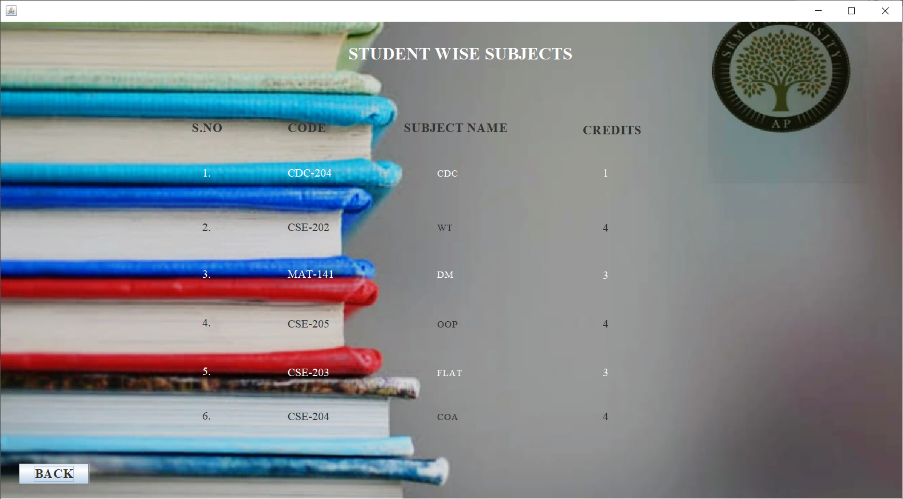

#### **13. VIEW EXAM MARKSHEET**

##### **CODE:**

package loginfile;

import java.awt.EventQueue;

import javax.swing.JFrame;

import javax.swing.JPanel;

import javax.swing.border.EmptyBorder;

import javax.swing.JLabel;

import javax.swing.JOptionPane;

import java.awt.Font;

import javax.swing.JTextField;

import javax.swing.JButton;

import java.awt.event.ActionListener;

import java.sql.Connection;

import java.sql.DriverManager;

import java.sql.PreparedStatement;

import java.sql.ResultSet;

import java.awt.event.ActionEvent;

import javax.swing.ImageIcon;

import java.awt.Color;

public class Exammarksviewstu extends JFrame {

/**

*

*/

private static final long serialVersionUID = 1L;

private JPanel contentPane;

private JTextField T1;

private JTextField T3;

private JTextField T4;

private JTextField T5;

private JTextField T6;

private JTextField T7;

private JTextField T8;

private JTextField T9;

/**

* Launch the application.

*/

public static void main(String[] args) {

EventQueue.invokeLater(new Runnable() {

public void run() {

try {

Exammarksviewstu frame = new Exammarksviewstu ();

frame.setVisible(true);

} catch (Exception e) {

e.printStackTrace();

}

}

});

}

/**

* Create the frame.

*/

public Exammarksviewstu () {

setDefaultCloseOperation(JFrame.EXIT_ON_CLOSE);

setBounds(100, 100, 1176, 683);

contentPane = new JPanel();

contentPane.setBorder(new EmptyBorder(5, 5, 5, 5));

setContentPane(contentPane);

contentPane.setLayout(null);

JLabel lblNewLabel = new JLabel("EXAM MARKS DETAILS");

lblNewLabel.setFont(new Font("Times New Roman", Font.BOLD, 22));

lblNewLabel.setBounds(442, 69, 287, 26);

contentPane.add(lblNewLabel);

JLabel lblNewLabel_1 = new JLabel("Name");

lblNewLabel_1.setFont(new Font("Times New Roman", Font.BOLD, 14));

lblNewLabel_1.setBounds(79, 141, 104, 13);

contentPane.add(lblNewLabel_1);

JLabel lblNewLabel_3 = new JLabel("Subject wise marks");

lblNewLabel_3.setFont(new Font("Times New Roman", Font.BOLD, 27));

lblNewLabel_3.setBounds(447, 212, 322, 35);

contentPane.add(lblNewLabel_3);

T1 = new JTextField();

T1.setBounds(188, 139, 159, 19);

contentPane.add(T1);

T1.setColumns(10);

JLabel lblNewLabel_4 = new JLabel("CDC");

lblNewLabel_4.setFont(new Font("Times New Roman", Font.BOLD, 14));

lblNewLabel_4.setBounds(131, 311, 71, 13);

contentPane.add(lblNewLabel_4);

T3 = new JTextField();

T3.setBounds(226, 309, 96, 19);

contentPane.add(T3);

T3.setColumns(10);

JLabel lblNewLabel_5 = new JLabel("WT");

lblNewLabel_5.setFont(new Font("Times New Roman", Font.BOLD, 14));

lblNewLabel_5.setBounds(131, 378, 46, 13);

contentPane.add(lblNewLabel_5);

T4 = new JTextField();

T4.setBounds(226, 376, 96, 19);

contentPane.add(T4);

T4.setColumns(10);

JLabel lblNewLabel_6 = new JLabel("DM");

lblNewLabel_6.setFont(new Font("Times New Roman", Font.BOLD, 14));

lblNewLabel_6.setBounds(131, 441, 46, 13);

contentPane.add(lblNewLabel_6);

T5 = new JTextField();

T5.setBounds(226, 435, 96, 19);

contentPane.add(T5);

T5.setColumns(10);

JLabel lblNewLabel_7 = new JLabel("OOP");

lblNewLabel_7.setFont(new Font("Times New Roman", Font.BOLD, 14));

lblNewLabel_7.setBounds(731, 311, 46, 13);

contentPane.add(lblNewLabel_7);

T6 = new JTextField();

T6.setBounds(836, 309, 96, 19);

contentPane.add(T6);

T6.setColumns(10);

JLabel lblNewLabel_8 = new JLabel("FLAT");

lblNewLabel_8.setFont(new Font("Times New Roman", Font.BOLD, 14));

lblNewLabel_8.setBounds(731, 378, 46, 13);

contentPane.add(lblNewLabel_8);

T7 = new JTextField();

T7.setBounds(836, 376, 96, 19);

contentPane.add(T7);

T7.setColumns(10);

JLabel lblNewLabel_9 = new JLabel("COA");

lblNewLabel_9.setFont(new Font("Times New Roman", Font.BOLD, 14));

lblNewLabel_9.setBounds(731, 441, 46, 13);

contentPane.add(lblNewLabel_9);

T8 = new JTextField();

T8.setBounds(836, 439, 96, 19);

contentPane.add(T8);

T8.setColumns(10);

JButton btnNewButton_1 = new JButton("BACK");

btnNewButton_1.setBackground(new Color(0, 255, 255));

btnNewButton_1.addActionListener(new ActionListener() {

public void actionPerformed(ActionEvent e) {

Studentpage window = new Studentpage();

window.frame.setVisible(true);

}

});

btnNewButton_1.setFont(new Font("Times New Roman", Font.BOLD, 18));

btnNewButton_1.setBounds(44, 589, 104, 35);

contentPane.add(btnNewButton_1);

JButton btnNewButton = new JButton("SEARCH");

btnNewButton.setBackground(Color.PINK);

btnNewButton.addActionListener(new ActionListener() {

public void actionPerformed(ActionEvent e) {

Function f=new Function();

ResultSet rs=null;

rs=f.find(T1.getText());

try {

if(rs.next()) {

T3.setText(rs.getString("CDC"));

T4.setText(rs.getString("WT"));

T5.setText(rs.getString("DM"));

T6.setText(rs.getString("OOPS"));

T7.setText(rs.getString("FLAT"));

T8.setText(rs.getString("COA"));

double[]R=new double[10];

R[0]=Double.parseDouble(T3.getText());

R[1]=Double.parseDouble(T4.getText());

R[2]=Double.parseDouble(T5.getText());

R[3]=Double.parseDouble(T6.getText());

R[4]=Double.parseDouble(T7.getText());

R[5]=Double.parseDouble(T8.getText());

R[6]=(R[0]+R[1]+R[2]+R[3]+R[3]+R[4]+R[5]);

String TOTAL=String.format("%.0f", R[6]);

T9.setText(TOTAL);

}

else {

JOptionPane.showMessageDialog(null,"No data for this Student Name");

}

}catch(Exception e2){

JOptionPane.showMessageDialog(null,e2.getMessage());

}

}

class Function{

ResultSet rs=null;

public ResultSet find(String s) {

try {

Class.forName("com.mysql.jdbc.Driver");

Connection con=DriverManager.getConnection("jdbc:mysql://localhost:3306/studentdatabase","root","");

PreparedStatement ps=con.prepareStatement("select * from exam_details where Name =?" );

ps.setString(1, s);

rs=ps.executeQuery();

/*while(rs.next()) {

String nameString=rs.getString("Student Name");

String cdcString=rs.getString("CDC");

String wtString=rs.getString("WT");

String dmString=rs.getString("DM");

String oopsString=rs.getString("OOPS");

String flatString=rs.getString("FLAT");

String coaString=rs.getString("COA");

System.out.println(nameString+" "+cdcString+" "+wtString+" "+dmString+" "+oopsString+" "+flatString+" "+coaString);

}

*/

} catch (Exception e2) {

// TODO: handle exception

System.out.println(e2);

}

return rs;

}

}

});

btnNewButton.setFont(new Font("Times New Roman", Font.BOLD, 18));

btnNewButton.setBounds(118, 193, 137, 26);

contentPane.add(btnNewButton);

JLabel lblNewLabel_2 = new JLabel("TOTAL");

lblNewLabel_2.setFont(new Font("Times New Roman", Font.BOLD, 16));

lblNewLabel_2.setBounds(467, 509, 71, 13);

contentPane.add(lblNewLabel_2);

T9 = new JTextField();

T9.setBounds(586, 507, 96, 19);

contentPane.add(T9);

T9.setColumns(10);

JLabel lblNewLabel_10 = new JLabel("");

lblNewLabel_10.setIcon(new ImageIcon("C:\\Users\\suhitha\\Downloads\\Webp.net-resizeimage (7).jpg"));

lblNewLabel_10.setBounds(0, 10, 1205, 626);

contentPane.add(lblNewLabel_10);

}

}

##### **OUTPUT:**

#### EXAM MARKSHEET

If “EXAM MARKSHEET” button is clicked in the “STUDENT DASHBOARD” page then the page directs to the “EXAM MARKS DETAILS” page and then students need to enter his/her name and after clicking on “SEARCH” button then the “subject wise marks and total marks” are displayed and if “BACK” button is clicked then the page redirects to the “STUDENT DASHBOARD” page.

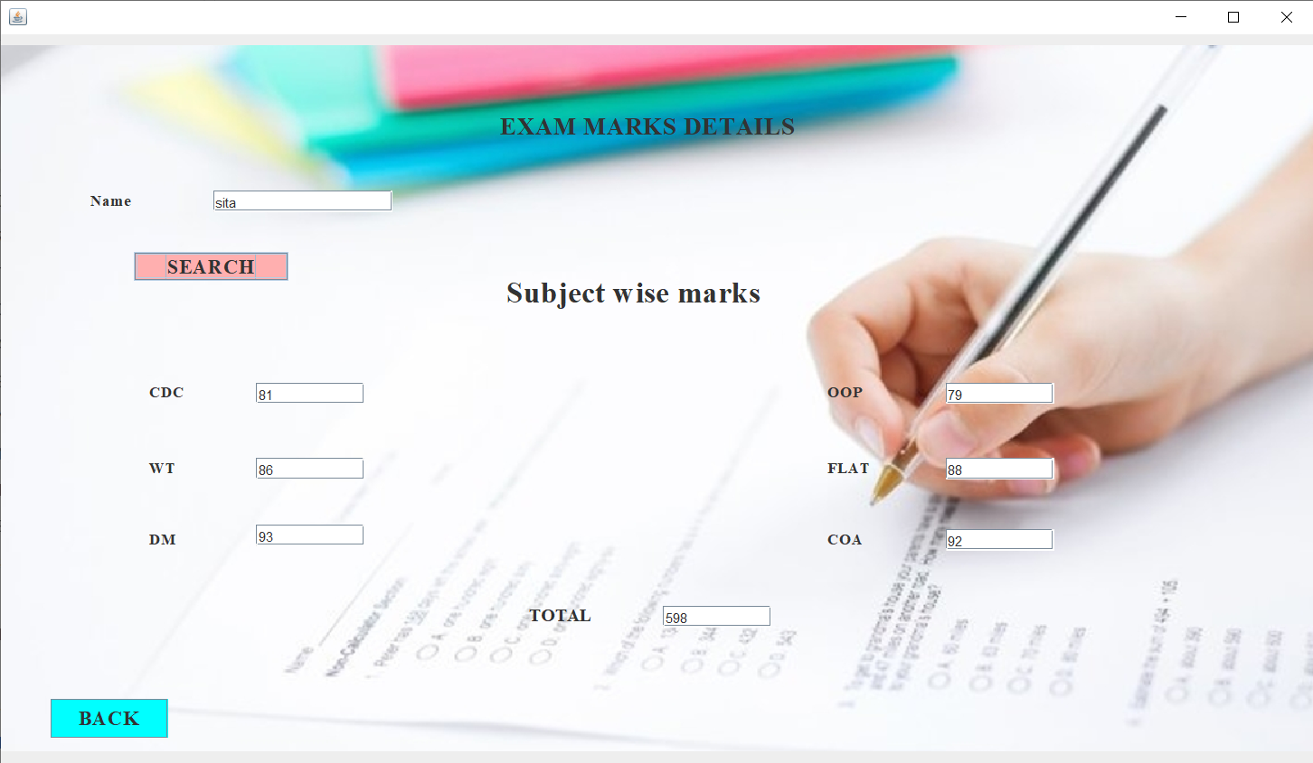

#### **14. VIEW FEE DETAILS**

##### **CODE:**

package loginfile;

import java.awt.EventQueue;

import javax.swing.JFrame;

import javax.swing.JPanel;

import javax.swing.border.EmptyBorder;

import javax.swing.JLabel;

import javax.swing.JOptionPane;

import java.awt.Font;

import javax.swing.JTextField;

import javax.swing.JButton;

import javax.swing.ImageIcon;

import java.awt.Color;

import java.awt.event.ActionListener;

import java.sql.Connection;

import java.sql.DriverManager;

import java.sql.PreparedStatement;

import java.sql.ResultSet;

import java.awt.event.ActionEvent;

public class Feedetails_student extends JFrame {

/**

*

*/

private static final long serialVersionUID = 1L;

private JPanel contentPane;

private JTextField T2;

private JTextField textField_1;

private JTextField T4;

private JTextField T5;

private JTextField T6;

private JTextField T3;

private JTextField T1;

/**

* Launch the application.

*/

public static void main(String[] args) {

EventQueue.invokeLater(new Runnable() {

public void run() {

try {

Feedetails_student frame = new Feedetails_student();

frame.setVisible(true);

} catch (Exception e) {

e.printStackTrace();

}

}

});

}

/**

* Create the frame.

*/

public Feedetails_student() {

setDefaultCloseOperation(JFrame.EXIT_ON_CLOSE);

setBounds(100, 100, 1227, 729);

contentPane = new JPanel();

contentPane.setBorder(new EmptyBorder(5, 5, 5, 5));

setContentPane(contentPane);

contentPane.setLayout(null);

JLabel lblNewLabel = new JLabel("FEE DETAILS");

lblNewLabel.setFont(new Font("Times New Roman", Font.BOLD, 30));

lblNewLabel.setBounds(503, 70, 214, 29);

contentPane.add(lblNewLabel);

JLabel lblNewLabel_1 = new JLabel("Name");

lblNewLabel_1.setForeground(Color.BLACK);

lblNewLabel_1.setFont(new Font("Times New Roman", Font.BOLD, 18));

lblNewLabel_1.setBounds(780, 184, 46, 13);

contentPane.add(lblNewLabel_1);

JLabel lblNewLabel_2 = new JLabel("StudentID");

lblNewLabel_2.setForeground(Color.BLACK);

lblNewLabel_2.setFont(new Font("Times New Roman", Font.BOLD, 16));

lblNewLabel_2.setBounds(780, 250, 83, 13);

contentPane.add(lblNewLabel_2);

JLabel lblNewLabel_3 = new JLabel("Section");

lblNewLabel_3.setForeground(Color.BLACK);

lblNewLabel_3.setFont(new Font("Times New Roman", Font.BOLD, 18));

lblNewLabel_3.setBounds(780, 314, 77, 13);

contentPane.add(lblNewLabel_3);

JLabel lblNewLabel_4 = new JLabel("Fee paid");

lblNewLabel_4.setForeground(Color.BLACK);

lblNewLabel_4.setFont(new Font("Times New Roman", Font.BOLD, 18));

lblNewLabel_4.setBounds(780, 385, 83, 19);

contentPane.add(lblNewLabel_4);

JLabel lblNewLabel_5 = new JLabel("Fee due");

lblNewLabel_5.setForeground(Color.BLACK);

lblNewLabel_5.setFont(new Font("Times New Roman", Font.BOLD, 18));

lblNewLabel_5.setBounds(780, 445, 83, 29);

contentPane.add(lblNewLabel_5);

T2 = new JTextField();

T2.setBounds(918, 183, 130, 19);

contentPane.add(T2);

T2.setColumns(10);

textField_1 = new JTextField();

textField_1.setBounds(626, 261, 130, -17);

contentPane.add(textField_1);

textField_1.setColumns(10);

T4 = new JTextField();

T4.setBounds(918, 313, 130, 19);

contentPane.add(T4);

T4.setColumns(10);

T5 = new JTextField();

T5.setBounds(918, 387, 130, 19);

contentPane.add(T5);

T5.setColumns(10);

T6 = new JTextField();

T6.setBounds(918, 452, 130, 19);

contentPane.add(T6);

T6.setColumns(10);

JButton btnNewButton = new JButton("BACK");

btnNewButton.addActionListener(new ActionListener() {

public void actionPerformed(ActionEvent e) {

Studentpage window = new Studentpage();

window.frame.setVisible(true);

}

});

btnNewButton.setBackground(Color.ORANGE);

btnNewButton.setForeground(Color.BLACK);

btnNewButton.setFont(new Font("Times New Roman", Font.BOLD, 18));

btnNewButton.setBounds(1016, 620, 117, 39);

contentPane.add(btnNewButton);

T3 = new JTextField();

T3.setBounds(918, 248, 130, 19);

contentPane.add(T3);

T3.setColumns(10);

JLabel lblNewLabel_6 = new JLabel("");

lblNewLabel_6.setBounds(202, 375, 46, 13);

contentPane.add(lblNewLabel_6);

JLabel lblNewLabel_7 = new JLabel("Name");

lblNewLabel_7.setForeground(Color.MAGENTA);

lblNewLabel_7.setFont(new Font("Times New Roman", Font.BOLD, 22));

lblNewLabel_7.setBounds(92, 245, 66, 19);

contentPane.add(lblNewLabel_7);

T1 = new JTextField();

T1.setBounds(225, 248, 141, 19);

contentPane.add(T1);

T1.setColumns(10);

JButton btnNewButton_1 = new JButton("SEARCH");

btnNewButton_1.addActionListener(new ActionListener() {

public void actionPerformed(ActionEvent e) {

Function f=new Function();

ResultSet rs=null;

rs=f.find(T1.getText());

try {

if(rs.next()) {

T2.setText(rs.getString("Name"));

T3.setText(rs.getString("StudentID"));

T4.setText(rs.getString("Section"));

T5.setText(rs.getString("Fee paid"));

T6.setText(rs.getString("Fee due"));

}

else {

JOptionPane.showMessageDialog(null,"No data for this Name");

}

} catch (Exception e2) {

JOptionPane.showMessageDialog(null,e2.getMessage());

// TODO: handle exception

}

}

class Function{

ResultSet rs=null;

public ResultSet find(String s) {

try {

Class.forName("com.mysql.jdbc.Driver");

Connection con=DriverManager.getConnection("jdbc:mysql://localhost:3306/studentdatabase","root","");

PreparedStatement ps=con.prepareStatement("select * from fee_details where Name=?");

ps.setString(1, s);

rs=ps.executeQuery();

} catch (Exception e2) {

// TODO: handle exception

System.out.println(e2);

}

return rs;

}

}

});

btnNewButton_1.setBackground(Color.ORANGE);

btnNewButton_1.setFont(new Font("Times New Roman", Font.BOLD, 18));

btnNewButton_1.setBounds(126, 314, 117, 40);

contentPane.add(btnNewButton_1);

JLabel lblNewLabel_8 = new JLabel("");

lblNewLabel_8.setIcon(new ImageIcon("C:\\Users\\suhitha\\Downloads\\Webp.net-resizeimage (8).jpg"));

lblNewLabel_8.setBounds(10, 10, 1203, 682);

contentPane.add(lblNewLabel_8);

}

}

##### **OUTPUT:**

#### FEE DETAILS

If “FEE DETAILS” button is clicked in the “STUDENT DASHBOARD” page then the page directs to the “FEE DETAILS” page and then students need to enter his/her name and after clicking on “SEARCH” button then the fee details are displayed and if “BACK” button is clicked then the page redirects to the “STUDENT DASHBOARD” page.

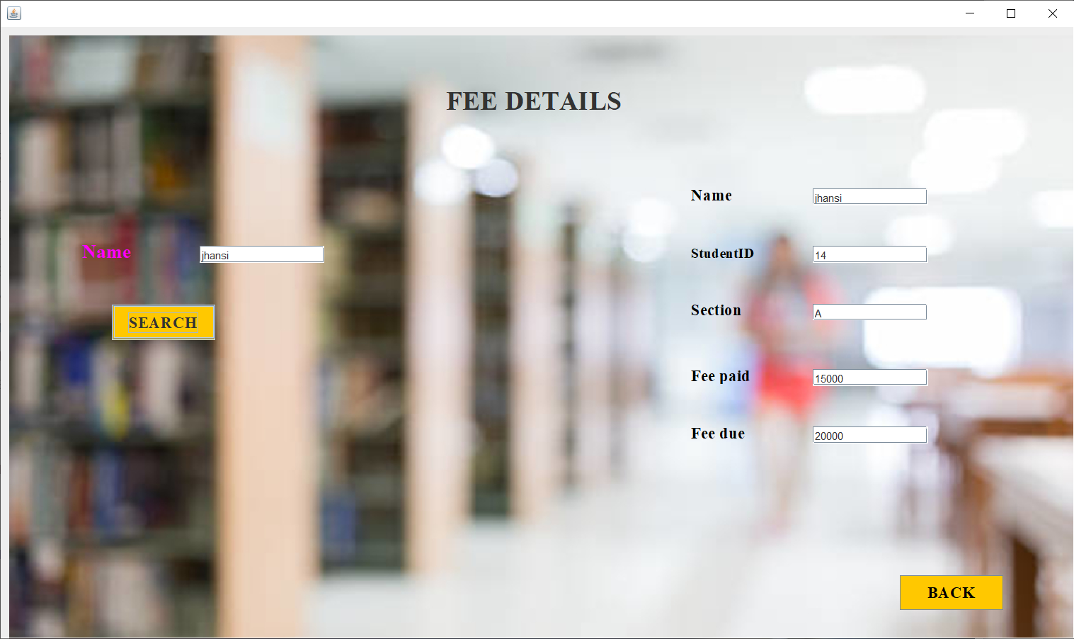

This is all about STUDENT HOME PAGE.

#### **MySQL Database snapshots**

The following images are the snapshots of the database (MySQL)

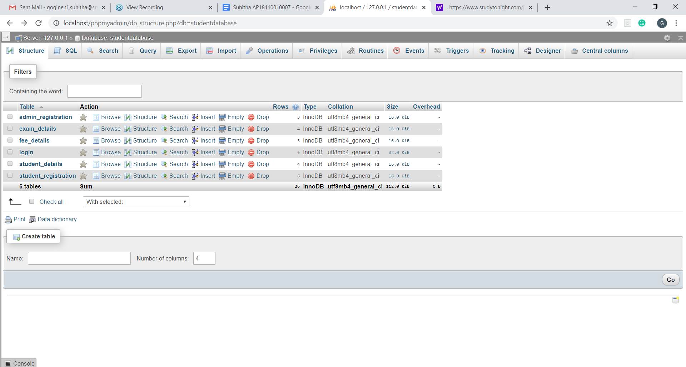

LOGIN

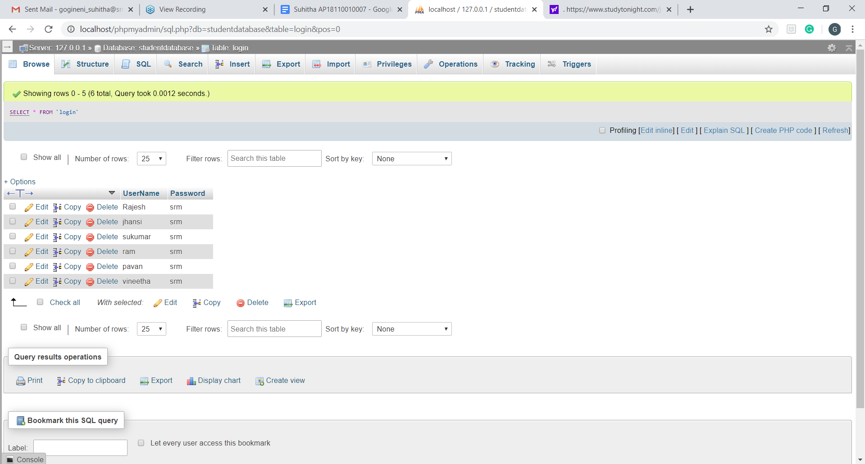

ADMIN REGISTRATION

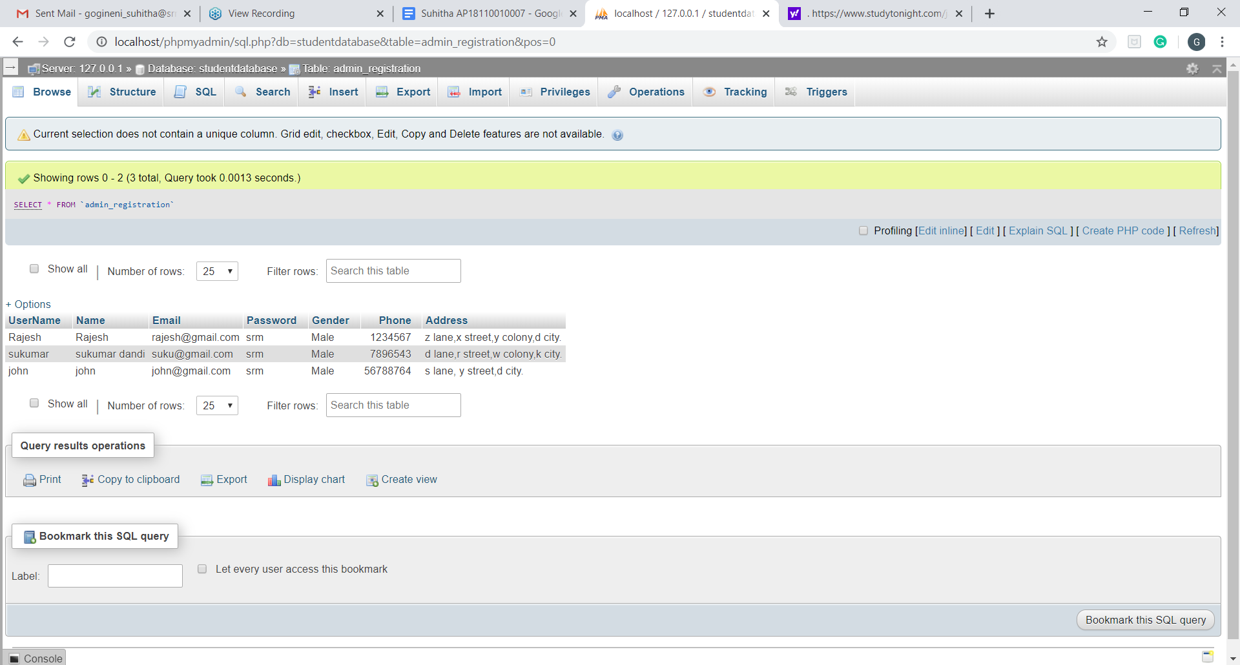

STUDENT REGISTRATION

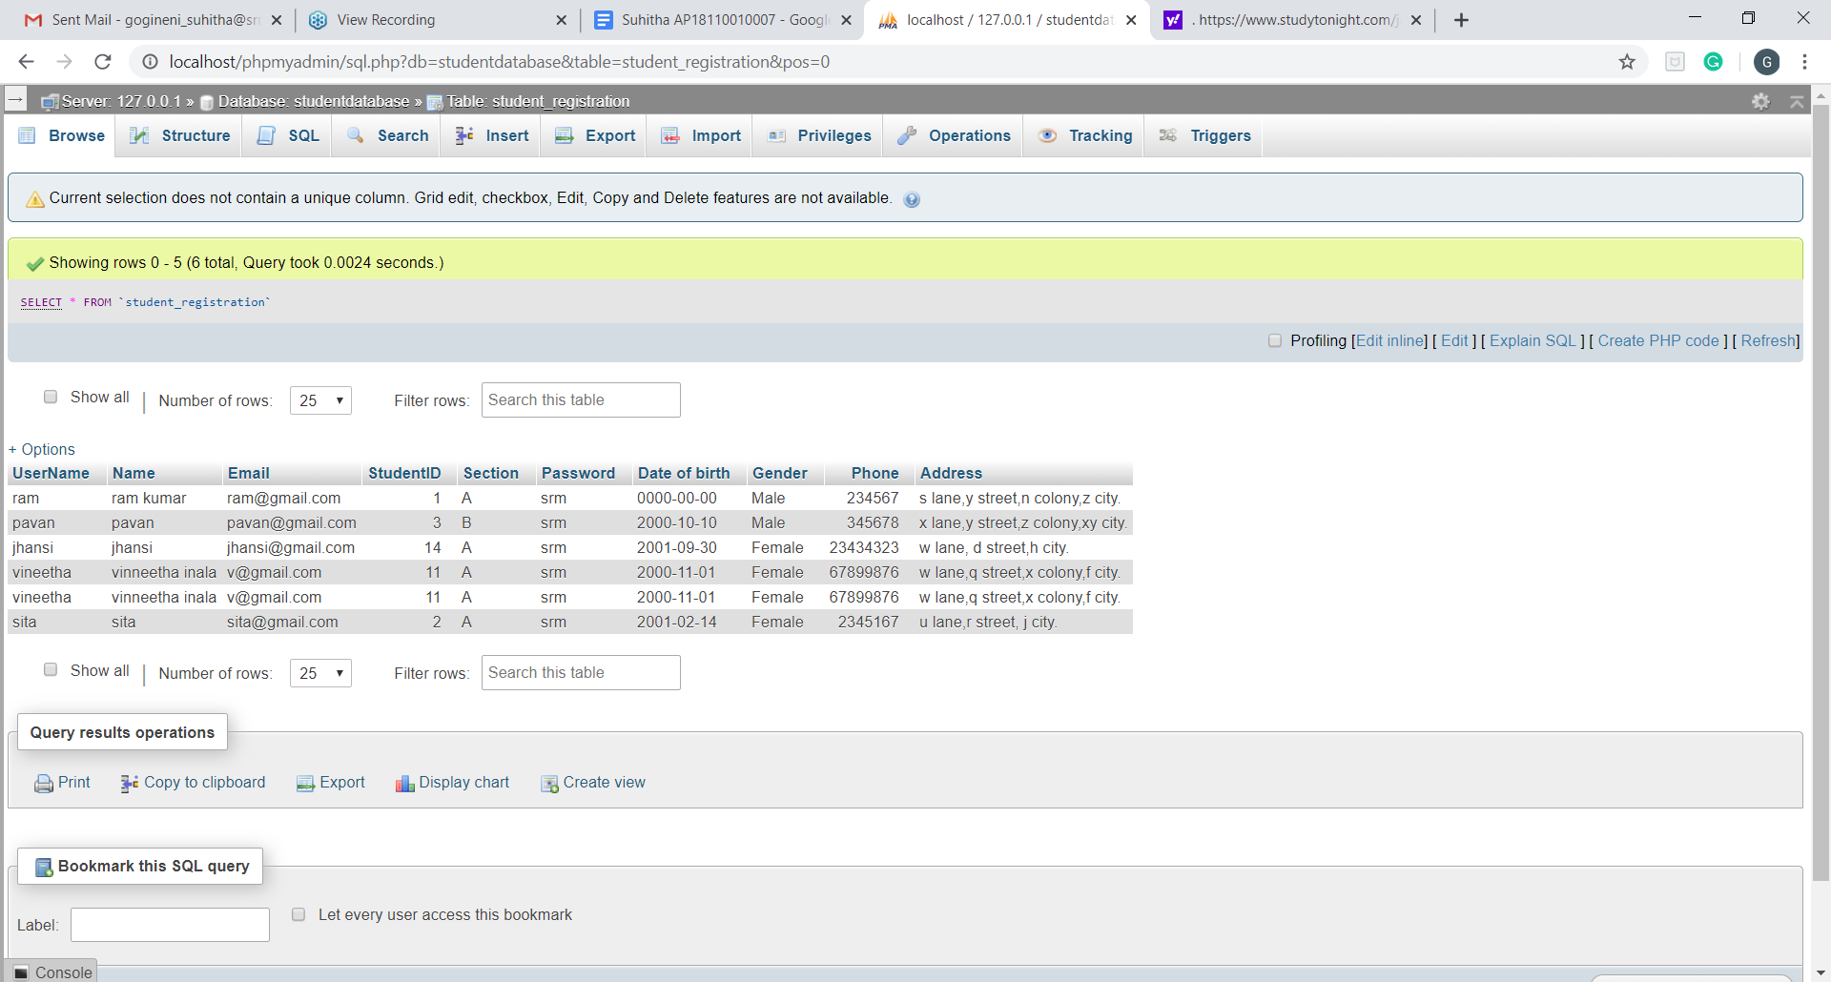

STUDENT DETAILS

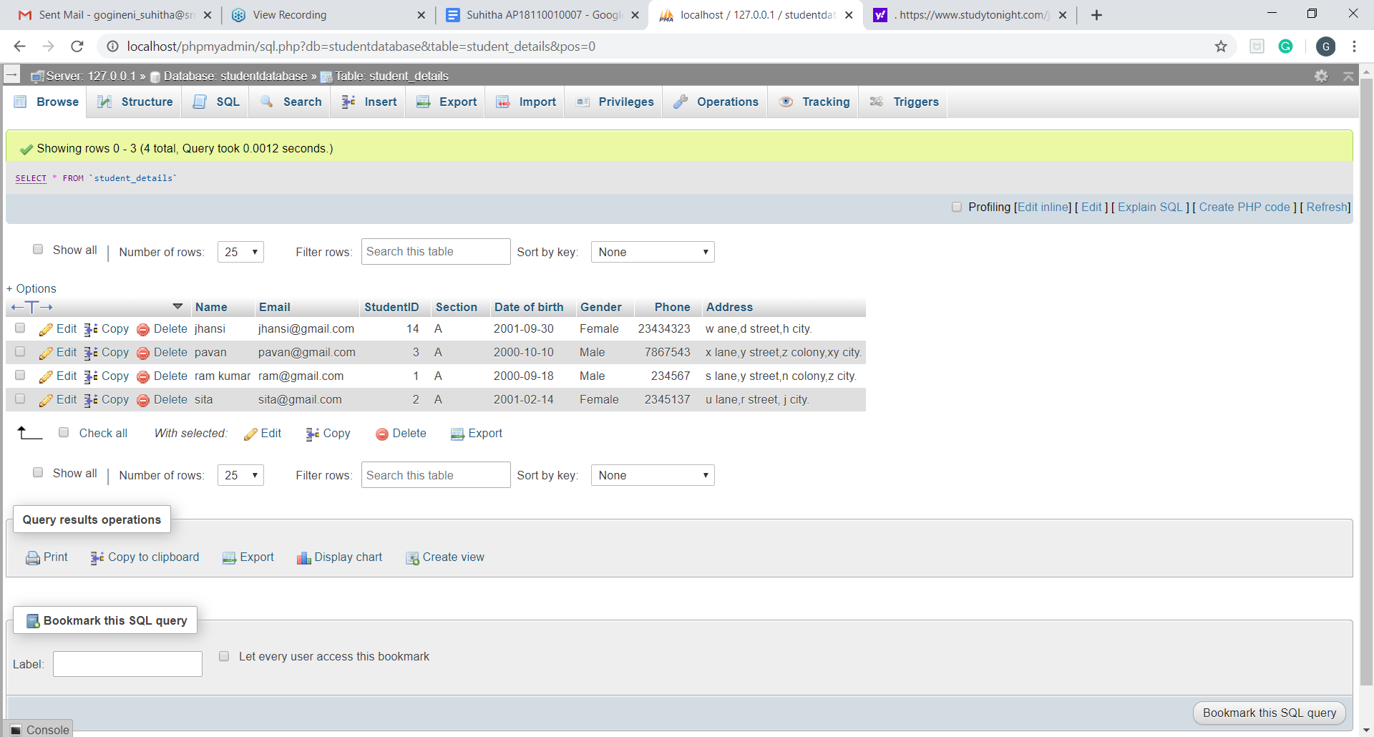

EXAM DETAILS

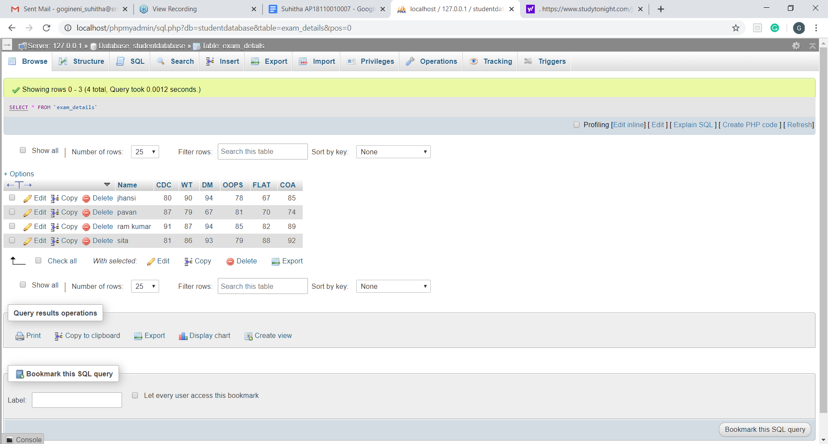

FEE DETAILS

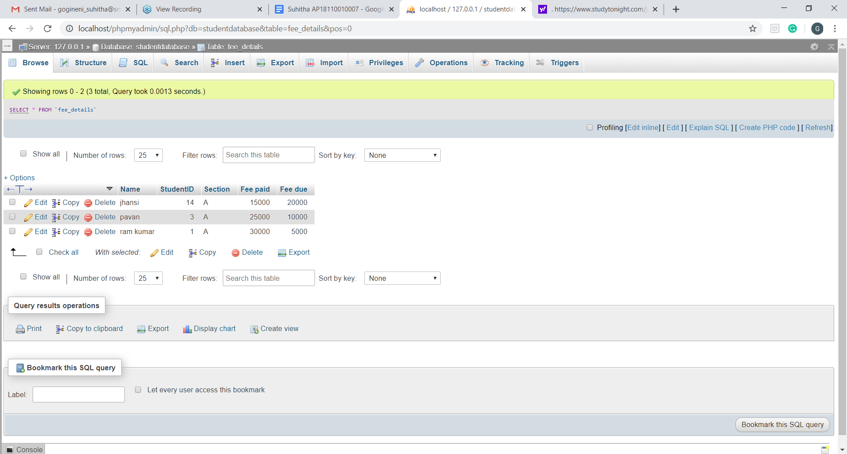

### **REFERENCES**

1[. https://www.studytonight.com/java/java-swing-components.php](https://www.studytonight.com/java/java-swing-components.php)

(Used for reference in order to understand the functionality of Jlabels, JRadioButton, Jtextfields, Jpasswordfield in detail)

2. <https://www.youtube.com/watch?v=OnmVTToq32I&feature=youtu.be>

(Used as a reference for installing the MySQL server)

3. <https://www.youtube.com/watch?v=IV6vGuHcQy8&feature=youtu.be>

(Used as a reference in order to understand the usage of PHPMyAdmin and understanding the insertion of data, creating a table)